City of Brooklyn Park
Request for EDA Action
Agenda Item: | 8.1 | Meeting Date: | January 20, 2026
Agenda Section: | Work Session | Prepared By: | Cara Donovan, Senior Planner
Resolution: | N/A | Presented By: | Cara Donovan, Senior Planner  Paul Mogush, Planning Director
Attachments: | 2 | Presented By: | Cara Donovan, Senior Planner  Paul Mogush, Planning Director
Item: | Review of two concept plans for properties owned by the Economic Development Authority in the Village Area as part of the Brooklyn Boulevard Corridor Plan.

Overview:

As part of the Brooklyn Boulevard Corridor Plan the project team has prepared concept plans for the properties owned by the Economic Development Authority near the intersection of Brooklyn Boulevard and Zane Avenue. These concept plans take into account existing housing and business spaces, property tax revenue, development type, and market feasibility. Focus groups will be held in late February, early March where concept plans will be available for comment by residents, business owners, property owners, students, and other community members. The project team are seeking input on the concept plans prior to the focus groups.

The project team presenting tonight includes City staff and the consulting team.

Background:

Long-Range Plans

The Brooklyn Boulevard Corridor Plan will provide an update to the existing Village Creek Master Plan/Shingle Creek Corridor Plan (2000). This Village Creek Plan envisions a walkable neighborhood with mixed-use development. Significant work was completed in the Village as a result of this plan including development of owner-occupied housing, improvement of stream health and natural functions, and public realm enhancements along Shingle Creek and roadways. Over $50 million in public investments have helped bring the neighborhood closer to the Village Creek Plan’s vision. The Brooklyn Boulevard Corridor Plan is considering how to strategically leverage future public and private investments to bring the neighborhood closer to this vision. A major component of the plan is guiding future development, in particular on the vacant land owned by the Economic Development Authority (depicted below). The project team has identified the following goals for these properties:

- Maximize tax returns.
  - City-wide economic development priorities revolve around building tax base and rebalancing the tax burden on residents. Tax base building should be evaluated on a ‘per-acre’ performance, rather than just total dollars.

- Encourage density.
  - Added density results in more activity, more foot traffic, and more customers for area businesses. These are essential ingredients to attract the type of place and businesses the city wants.

- Diversify area housing stock by prioritizing market rate and home ownership options.
  - Providing a greater diversity of housing allows for more places to live, for more people, at more stages of life. Prioritizing market rate housing and ownership options meets a community and economic need that isn’t sufficiently offered with the current area housing stock.

- Strategically use City/EDA tools to encourage desired development.
  - There have been significant public resources invested into the Village Area. Any additional potential investments must balance this reality with development-specific outcomes and long-term fiscal impacts.

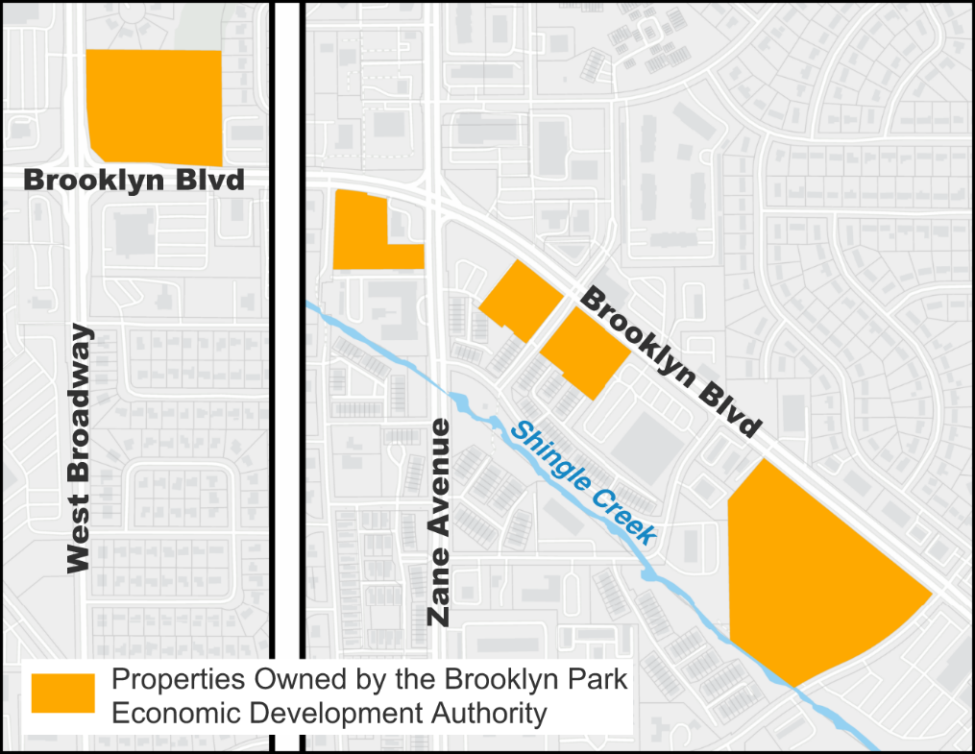

Development Concepts and Requested Feedback

The project team reviewed different types of development that could be on the EDA sites. Housing types included small lot single-family and duplexes, middle housing (e.g. townhomes, 8-plexes), and multi-family housing, both affordable and market rate. The project team also considered where new retail was viable based on the market study.

Based on the goals for the EDA properties, findings of the market study, and financial analysis of different development types two development concepts have been developed for consideration.
- The first concept depicts a mix of middle housing (primarily townhouses) and multi-family housing (primarily market rate apartments). The middle housing is concentrated on the south sides of properties, which extends the pattern of townhomes alongside Shingle Creek. Multi-family housing fronts Brooklyn Boulevard where there is greater access to public transit and retail.
- The second concept depicts a variety of multi-family housing projects. Both concepts include proposals for public enhancements including new roads, open space, and trails on the EDA-owned properties.

The project team will be conducting open houses in the last week of February and early March. These focus groups will be hosted at community gathering spaces, city-owned locations, schools, and other locations along and near Brooklyn Boulevard. Focus groups are open to all and are intended to host a wide variety of individuals including young people, residents, business owners, community leaders, developers, and others. The focus groups will concentrate on collecting feedback for two concept plans for the Village Area which are intended to promote discussion, deliberate the benefits or drawbacks of different scenarios, and identify any new elements for consideration.

The project team is seeking feedback from the Economic Development Authority on the concept plans presented tonight. Feedback can be integrated into the concept plans prior to the focus groups. Feedback provided tonight, at the February EDA meeting focused on the Station Area and Corridor, and at the focus groups will be integrated into a corridor-wide design which will be brough back for public consideration at an open house this spring. Feedback during all these meetings will be considered for recommendations in the Brooklyn Boulevard Corridor Plan.

Next Steps:

The project team will continue to conduct public engagement and work with other agencies.

The project team has started reviewing existing conditions of the Station Area and the Corridor. Similar to the Village, concepts will be developed and brought for EDA consideration on February 17, 2026.

Focus groups will be scheduled and promoted starting in mid-January and will be hosted in the last week of February and early March. Developers and property owners will be invited to discuss concepts with City staff at scheduled times.

The plan’s vision, goals, recommendations, designs, and implementation plan will be drafted for a community-wide open house that will take place in spring 2026.

The plan will be brought for City Council consideration in late spring/early summer 2026 for adoption.

Attachments:

8.1A Executive Summary for Market Analysis for the Brooklyn Boulevard Corridor Plan
8.1B Draft Market Analysis for the Brooklyn Boulevard Corridor Plan

