

Brooklyn Blvd Corridor Plan
March 16, 2026 Economic Development Authority

Agenda
- Project Overview
- Station Area
- Station Area Approach
- Northwinds Plaza Site
- Corridor Approach
- Georgia Site
- Redeemer Church Site
- Village Area Updates
- Overall Corridor
- Next Steps

Project Overview


PROJECT OVERVIEW
BROOKLYN BOULEVARD
NOBLE AVE

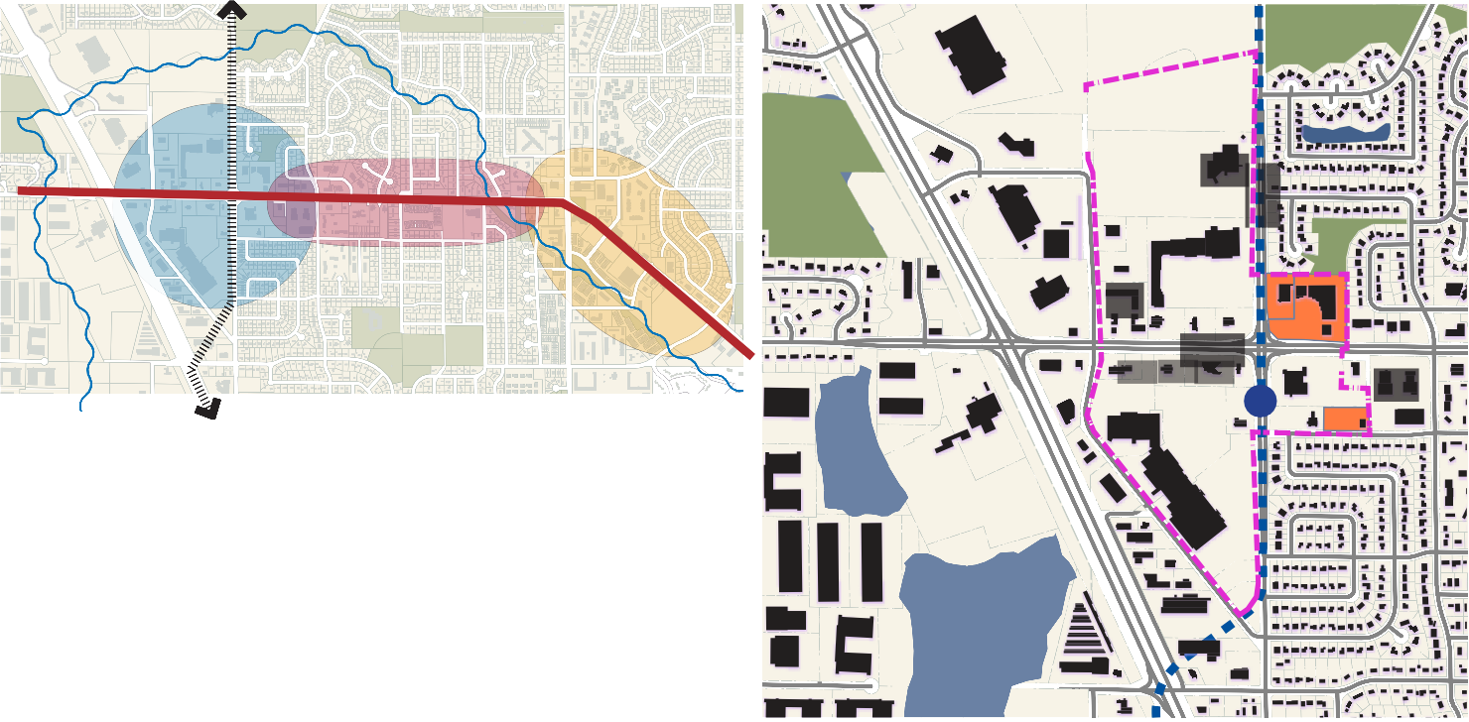
STATION AREA
BROADWAY
BROOKLYN BLVD
CORRIDOR

VILLAGE AREA
Revive Church
ZANE AVE
West Broadway

Car dealer
Auto shop
BROOKLYN BLVD
Dragon Star

Boulevard
Brooklyn

Bank Ban Bank
k

Northwinds Plaza
Car dealer

Planet Fitness
Car dealer

Vacant

Target

PROJECT OVERVIEW


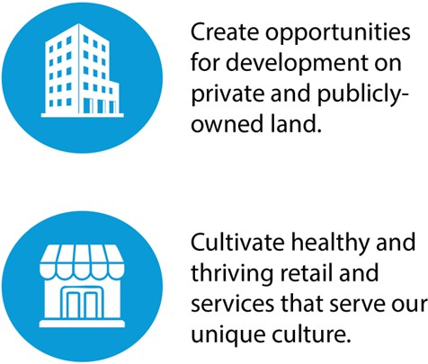
Development

Retail/ Services
.
Housing

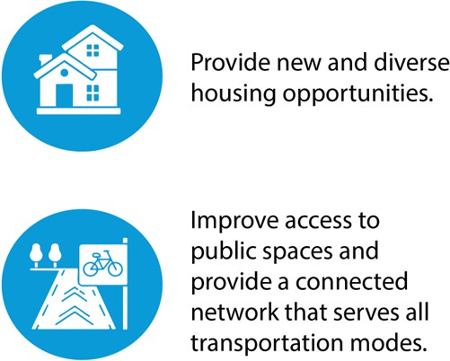
Public Spaces and Connectivity

Safety

STATION AREA TODAY

MARKET

We have sufficient restaurant and retail space to meet customer demand today. New retail should come on line with new housing.

Empty commercial space is more likely to support small, locally owned businesses, rather than large, national chains

There is a strong need for new housing options but rents must match what the local market can afford.

Having more homes (higher density) close to the Village and Station Area supports shops, transit and walkable places.

The light rail will help the corridor grow over time, but development and rent changes will happen slowly, not all at once.

Station Area

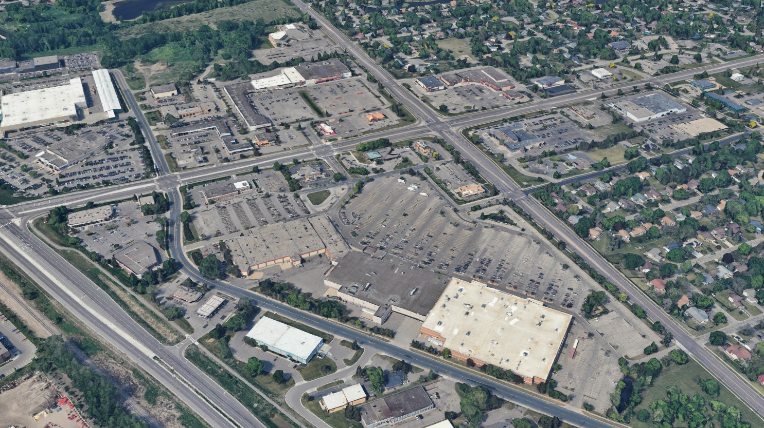
STATION AREA OVERVIEW
Northwinds
Plaza

Star
Dragon

Fitness
Planet

(vacant)

Target

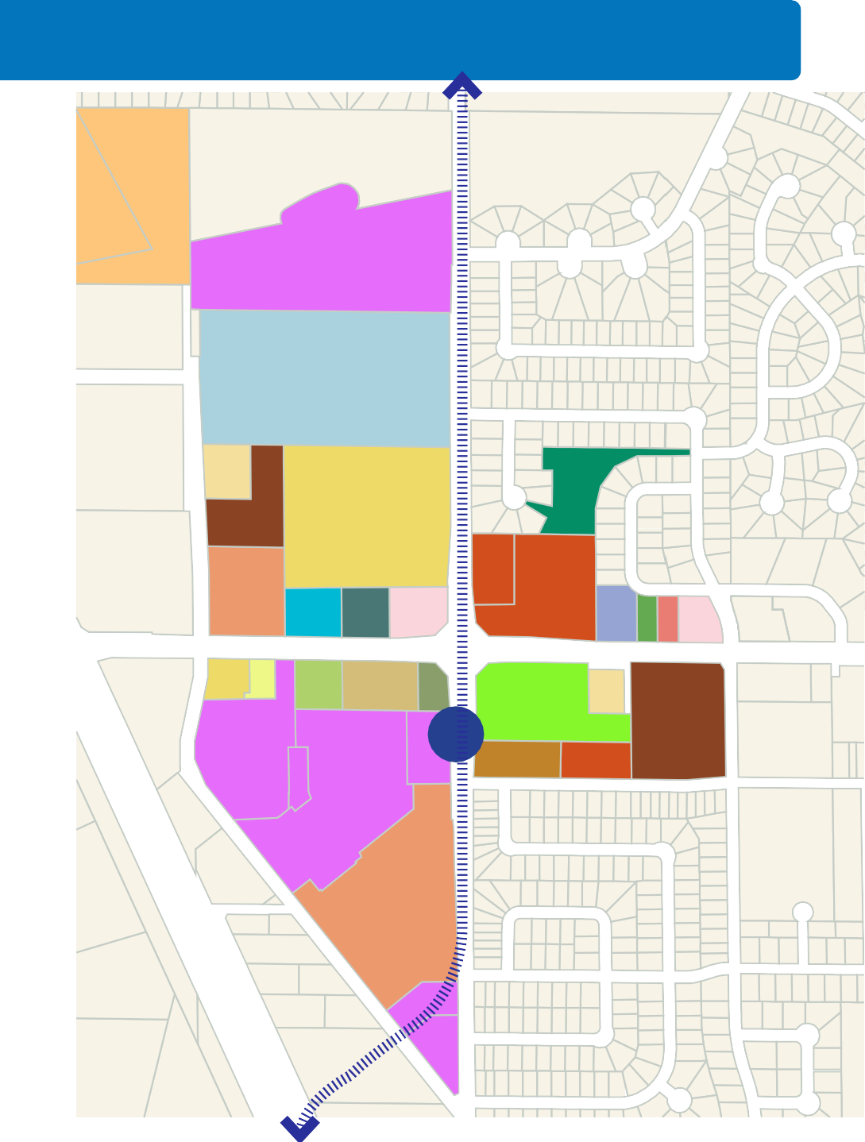
STATION AREA OVERVIEW: ANALYSIS
Fine
Evan Free Church
Morries
Dragon Star
EDA
Brooklyn Boulevard
Buerkle
Morries
Fine
Target
West Broadway
Blue Line Extension
West Broadway
Rt 705
Rt 723
West Broadway
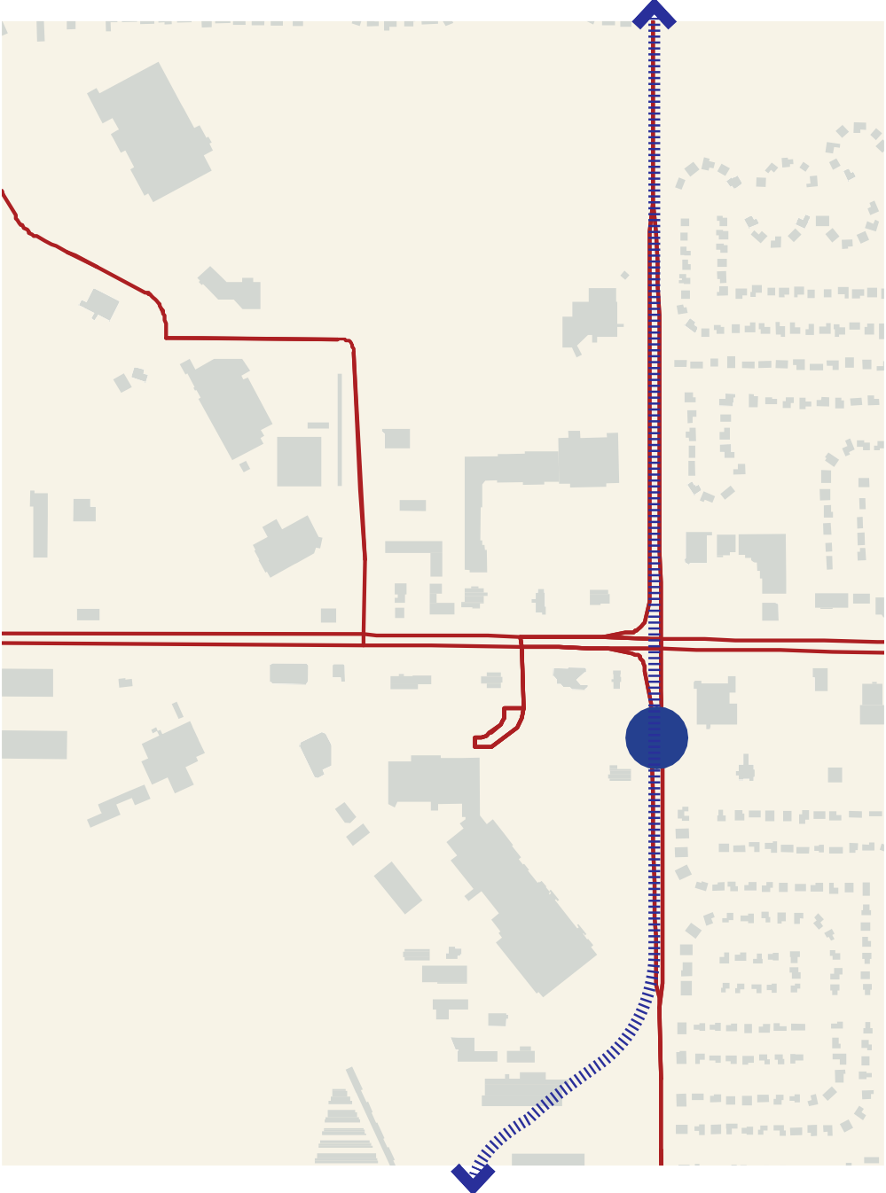
Property Ownership Patterns
Rt 725
Rt 724
Brooklyn Boulevard
Starlite Transit Center
Crystal Lake Trail
The area is a mix of large and small property owners.

Transit
The Blue Line Extension will run on Broadway. The Starlite Transit Center currently serves Rt 705, 723, 724, 725, and 764.
Consideration should be given to repositioning the Transit Center, converting it to a full service Mobility Hub and using it as a terminus for the potential extension of the Metro D Line BRT that currently terminates in Brooklyn Center.
Parks, Open Spaces, and Trails
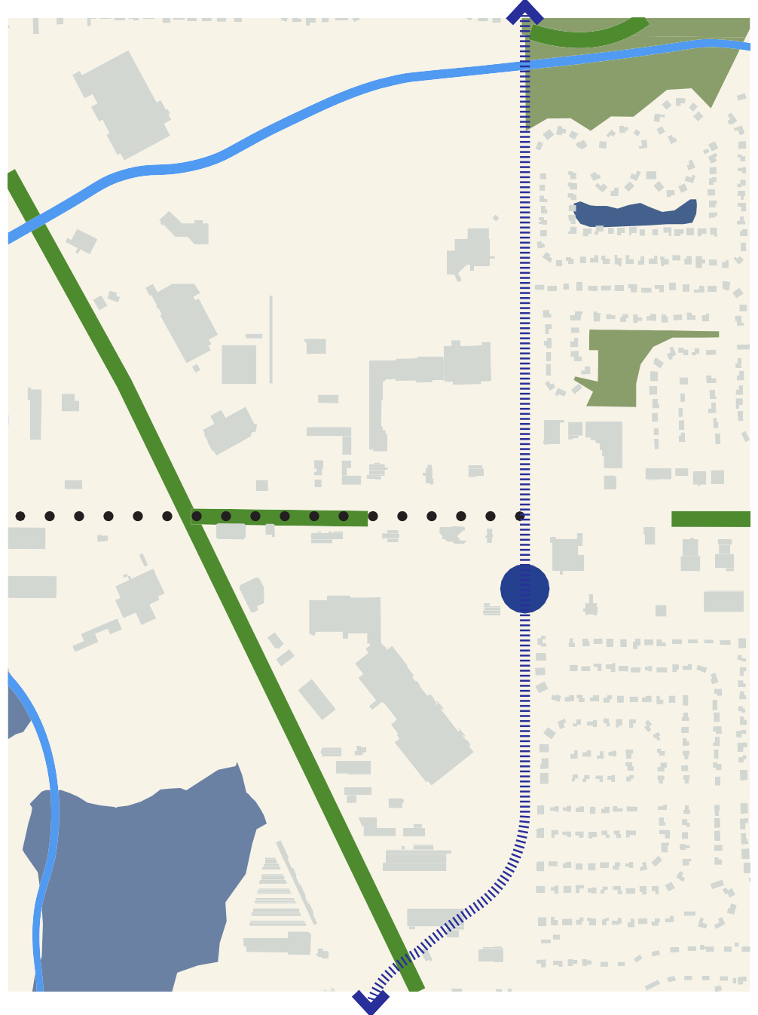
Shingle Creek passes to the north of the area and terminates at Broadway. The Crystal Lake Trail runs along the west side and connects into the area. In the future, the Weaver Lake Trail will traverse the area, although its exact route has not yet been determined. There are no parks on the west side of Broadway because that portion of the corridor was developed exclusively as a commercial district.
Tessman Park
Shingle Creek
Weaver Lake Trail Phase 1
Brooklyn Boulevard


STATION AREA OVERVIEW: ANALYSIS

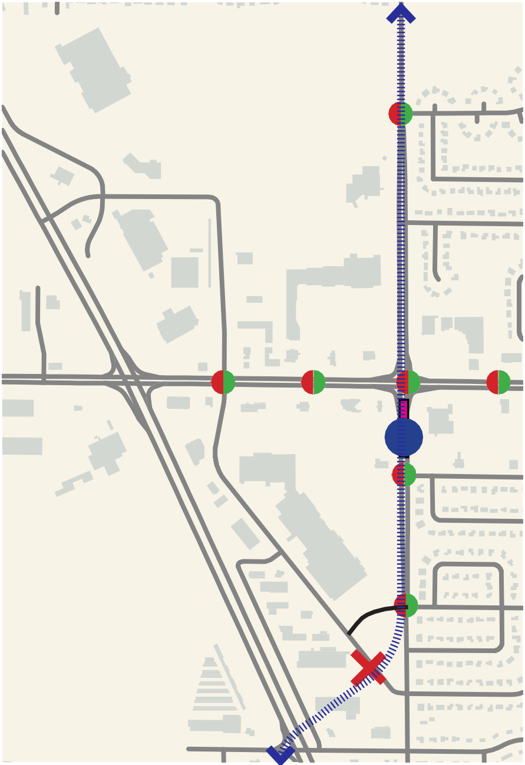
Street Network
Candlewood Ave
Brooklyn Boulevard
75th Ave
West Broadway
West Broadway
West Broadway
There is no internal street network. The BLRT Project will alter access to properties by preventing left turns into driveways between Candlewood and 75th Ave

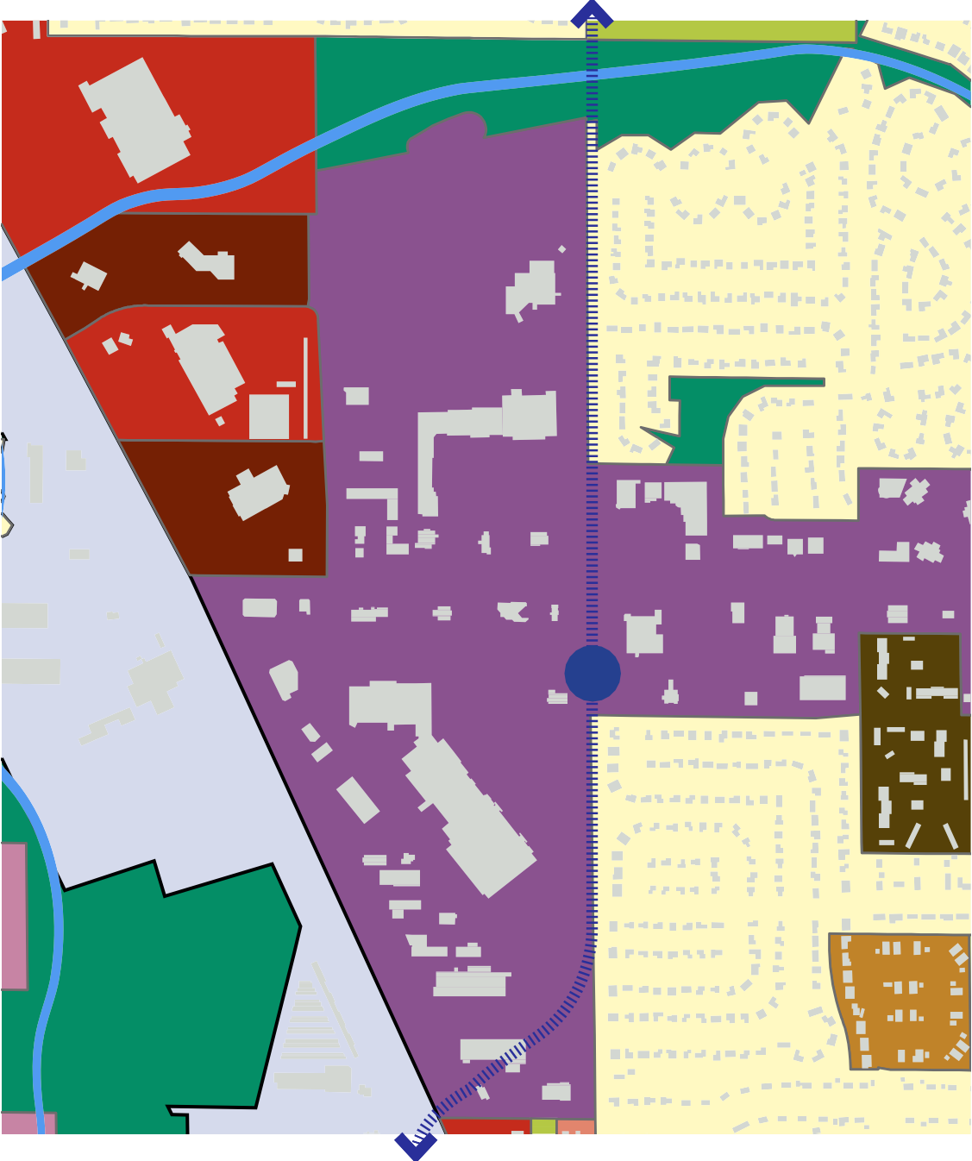
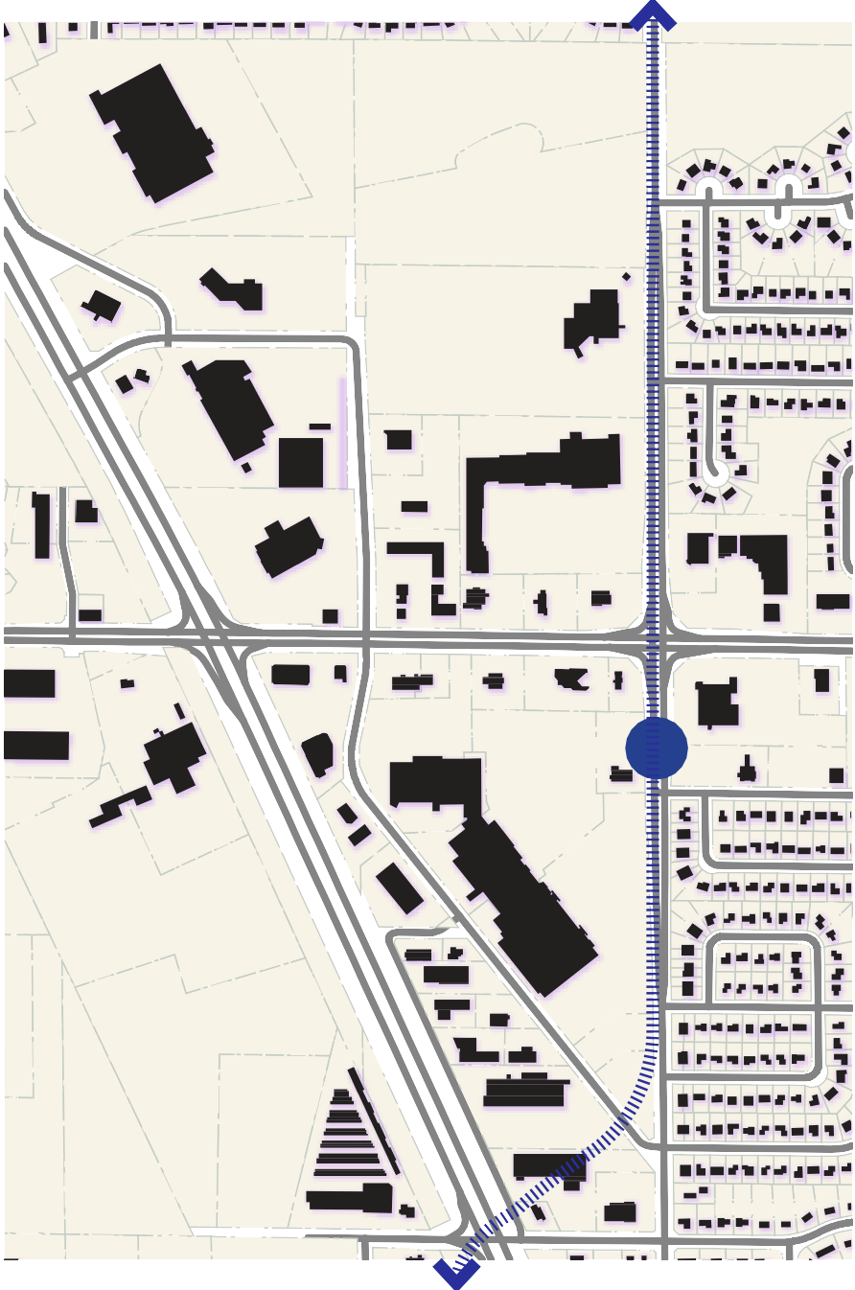


TOD-C
Brooklyn Boulevard
Zoning
Brooklyn Boulevard
Development Pattern
Transit Oriented Development Center District


R1
Detached Single-Family Estate District


R3
Detached Single-Family & Two-Family


R5
Multiple Family

B3
General Buisness District
B4
Vehicle Sales amd Showroom
OP
Open Space and Parks
I
General Industrial

The area is dominated by the typical suburban pattern of strip malls set back from the street with outbuildings and drive through establishments located on the arterials.

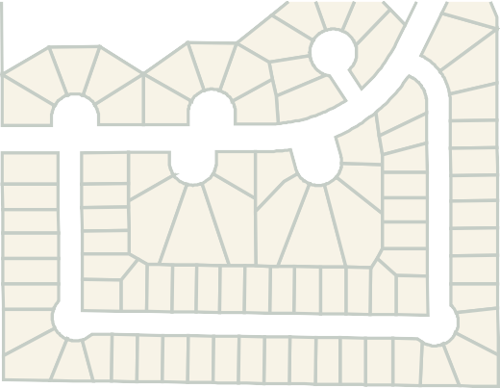
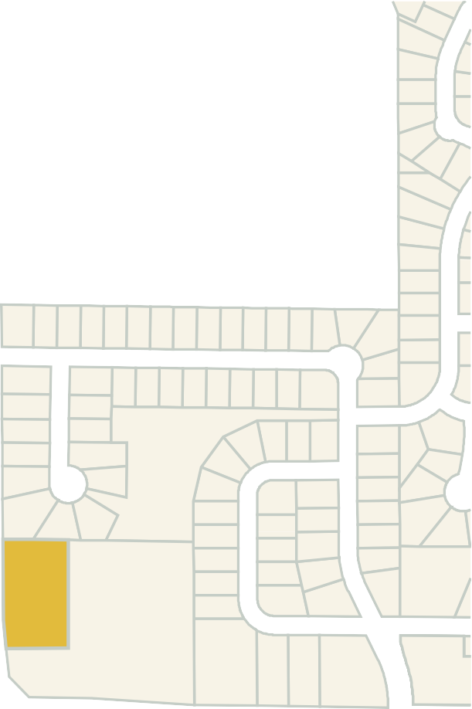
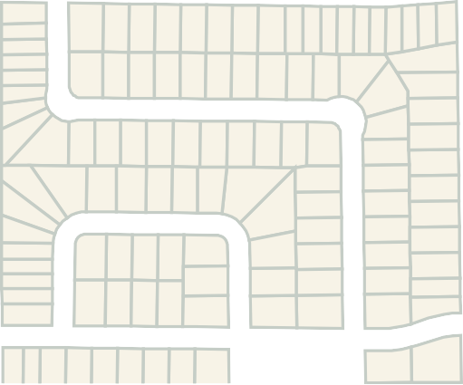





STATION AREA OVERVIEW: ANALYSIS
Brooklyn Boulevard

Soft and Susceptible Properties
While the area has a few strong anchor businesses, much of the land is underutilized or incompatible with transit oriented development and design principles.
West Broadway

Phase 1: Infill Development
Existing parking lots, vacant
Phase 2 : Redevelopment
drive thru branch banks,
auto oriented uses that will be phased out over time

Station Area
Approach

STATION AREA OVERVIEW APPROACH
HIGH PERFORMING CONNECTED PUBLIC REALM DISTRIBUTED PARKS HIGH TO LOW(ER) DENSITY

Medium Density Res.
West Broadway
West Broadway
West Broadway

Neighborhood

Brooklyn Boulevard

Brooklyn Boulevard

Highway

High Density Res.

Brooklyn Boulevard
Anchor Retail

TOD Mix Use

MH

Anchor Retail

Highway

Neighborhood

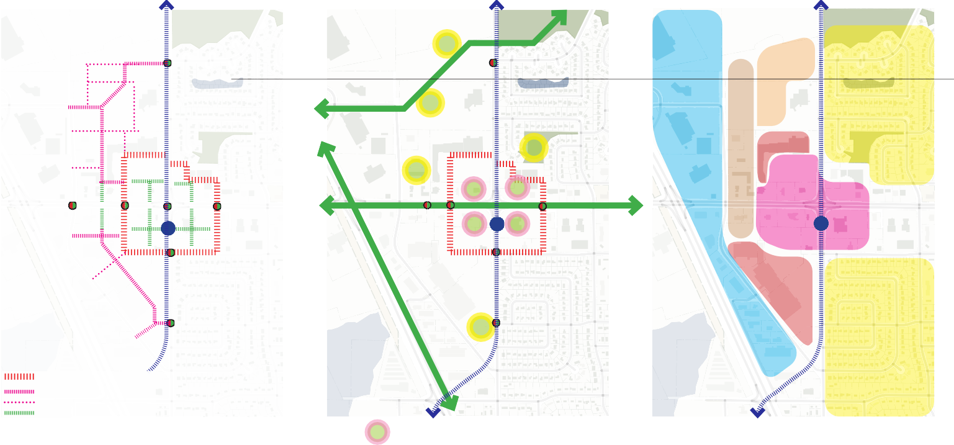
Primary Ring Road Secondary Roads Tertiary Roads Pedestrian Connections
High performance ring road: on street parking, stormwater, connectivity, ensuring access to storefronts
Secondary Roads: access to core, mixed use
Tertiary: primarily pedestrian connections from arterial to core

Public spaces for gathering and stormwater for the core.

Neighborhood spcaes.

High Density Res. moves west to east gradually stepping down to lower‑density housing, creating a smooth transition into the neighborhood

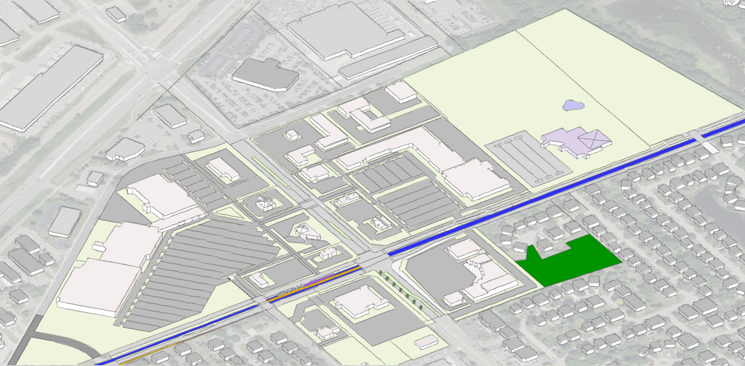
Brooklyn Boulevard
North
LRT STATION
West Broadway
STATION AREA OVERVIEW : APPROACH

Menards

Revive
Brooklyn Boulevard
West Broadway
Church

Star
Dragon

Target
Northwinds Plaza
Park Lawn Park

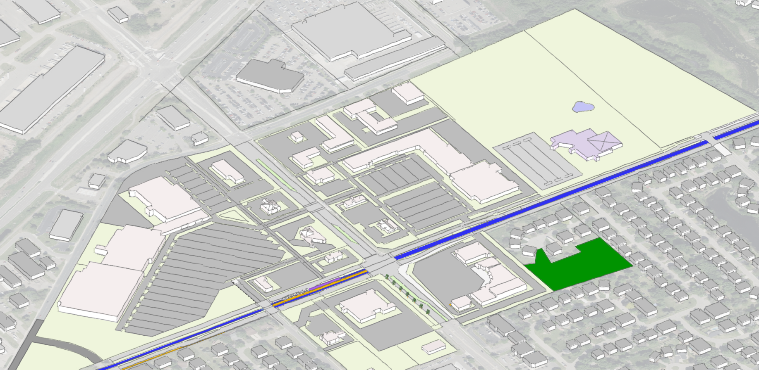
STATION AREA : RING ROAD
Brooklyn Boulevard
Brooklyn Boulevard
North
West Broadway
LRT STATION
West Broadway

Menards

Church
Revive

Star
Dragon

Target
Northwinds Plaza
Park Lawn Park





STATION AREA OVERVIEW : PHASE 1 INFILL DEVELOPMENT
Brooklyn Boulevard
North
FUTURE PEDESTRIAN ORIENTED RETAIL STREET
West Broadway
LRT STATION
West Broadway

Menards

Church
Revive

Star
Dragon

Target
Northwinds Plaza
Park Lawn Park

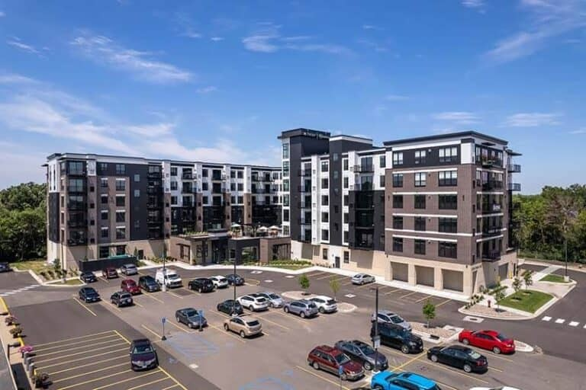
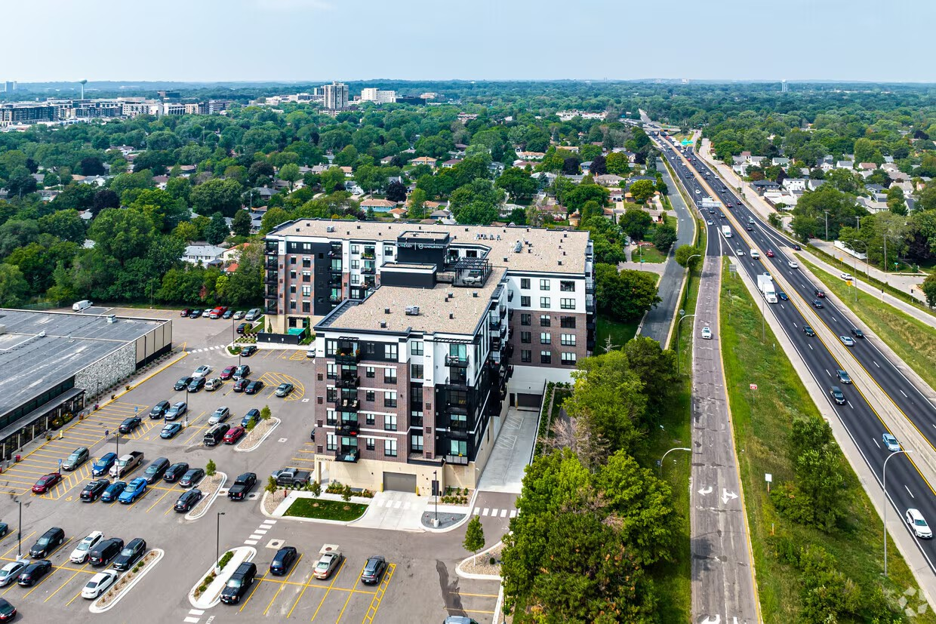
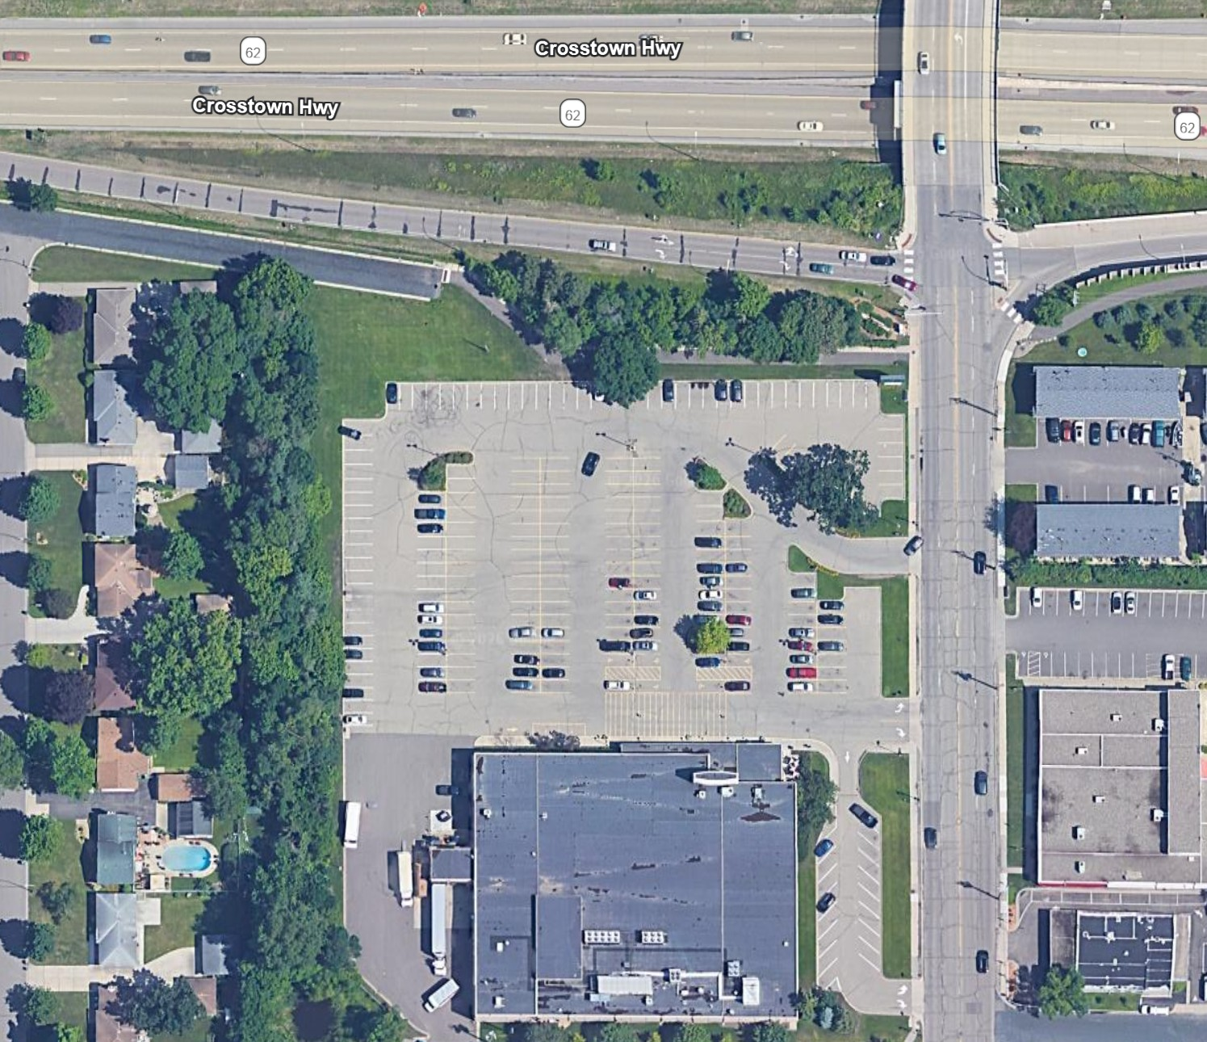
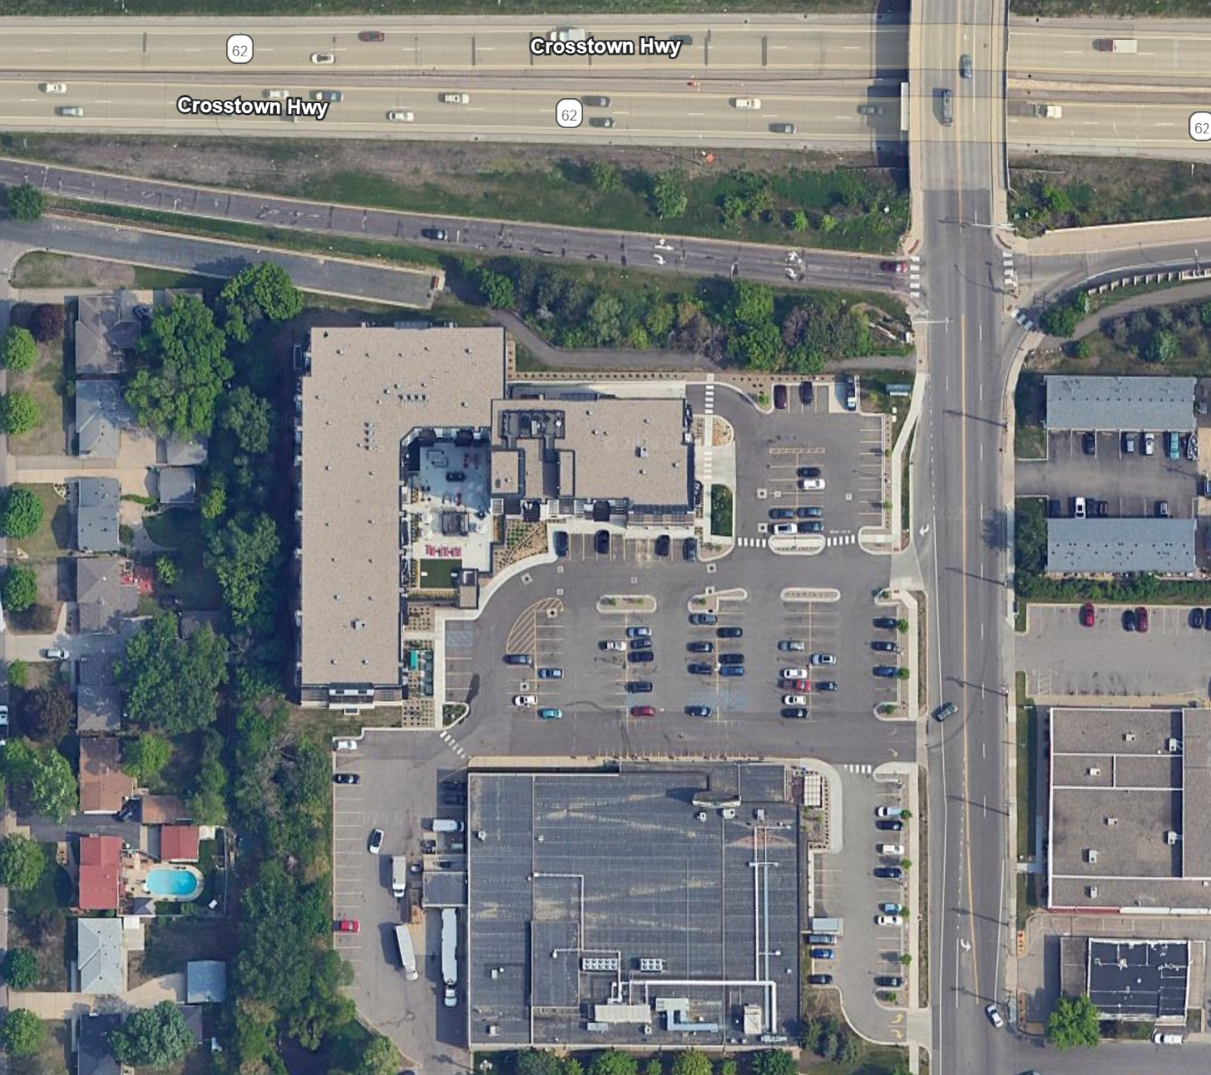
INFILL DEVELOPMENT: 6200 Penn Ave S, Richfield, MN

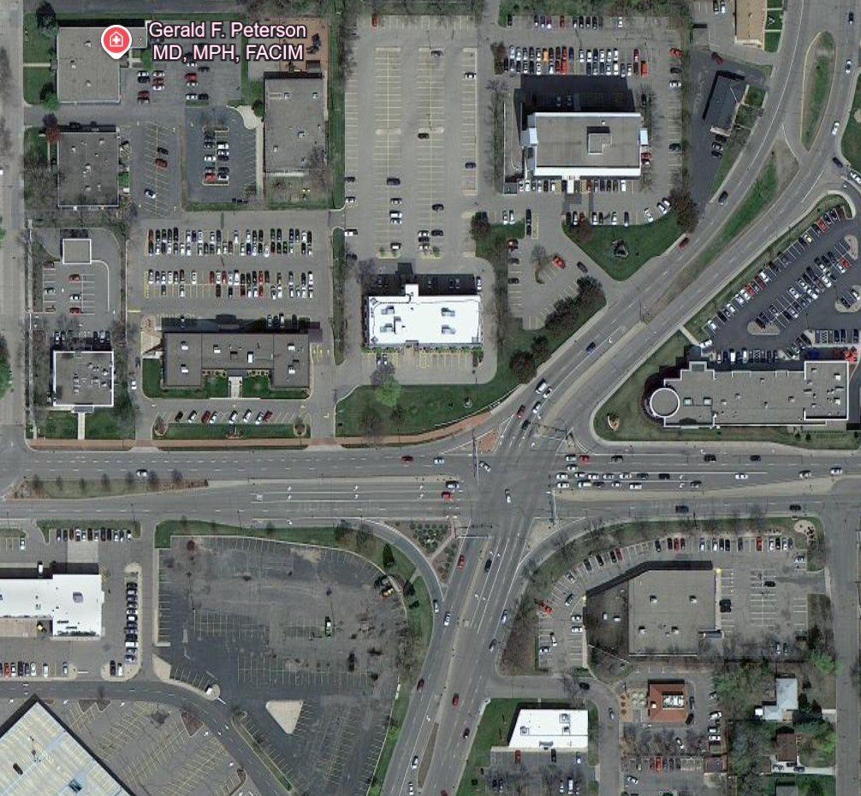
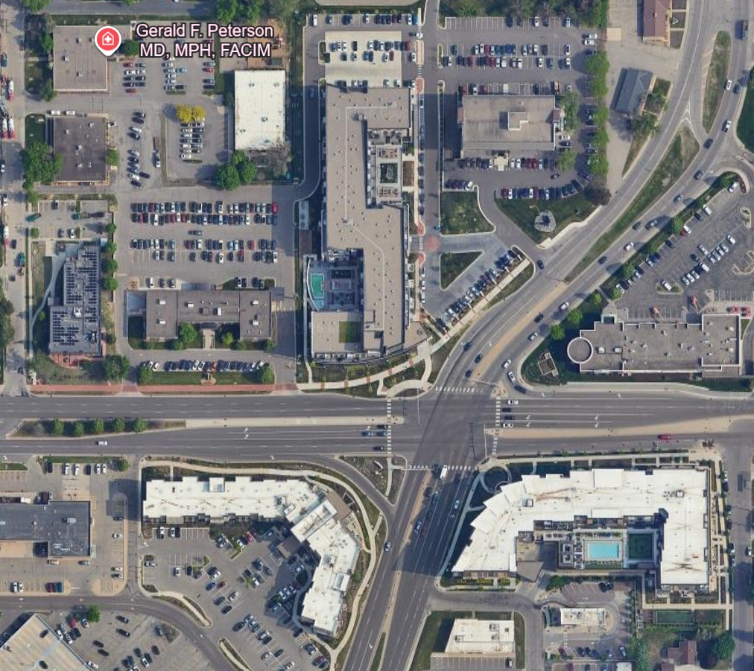
REDEVELOPMENT: WEST 66TH ST & YORK AVE S

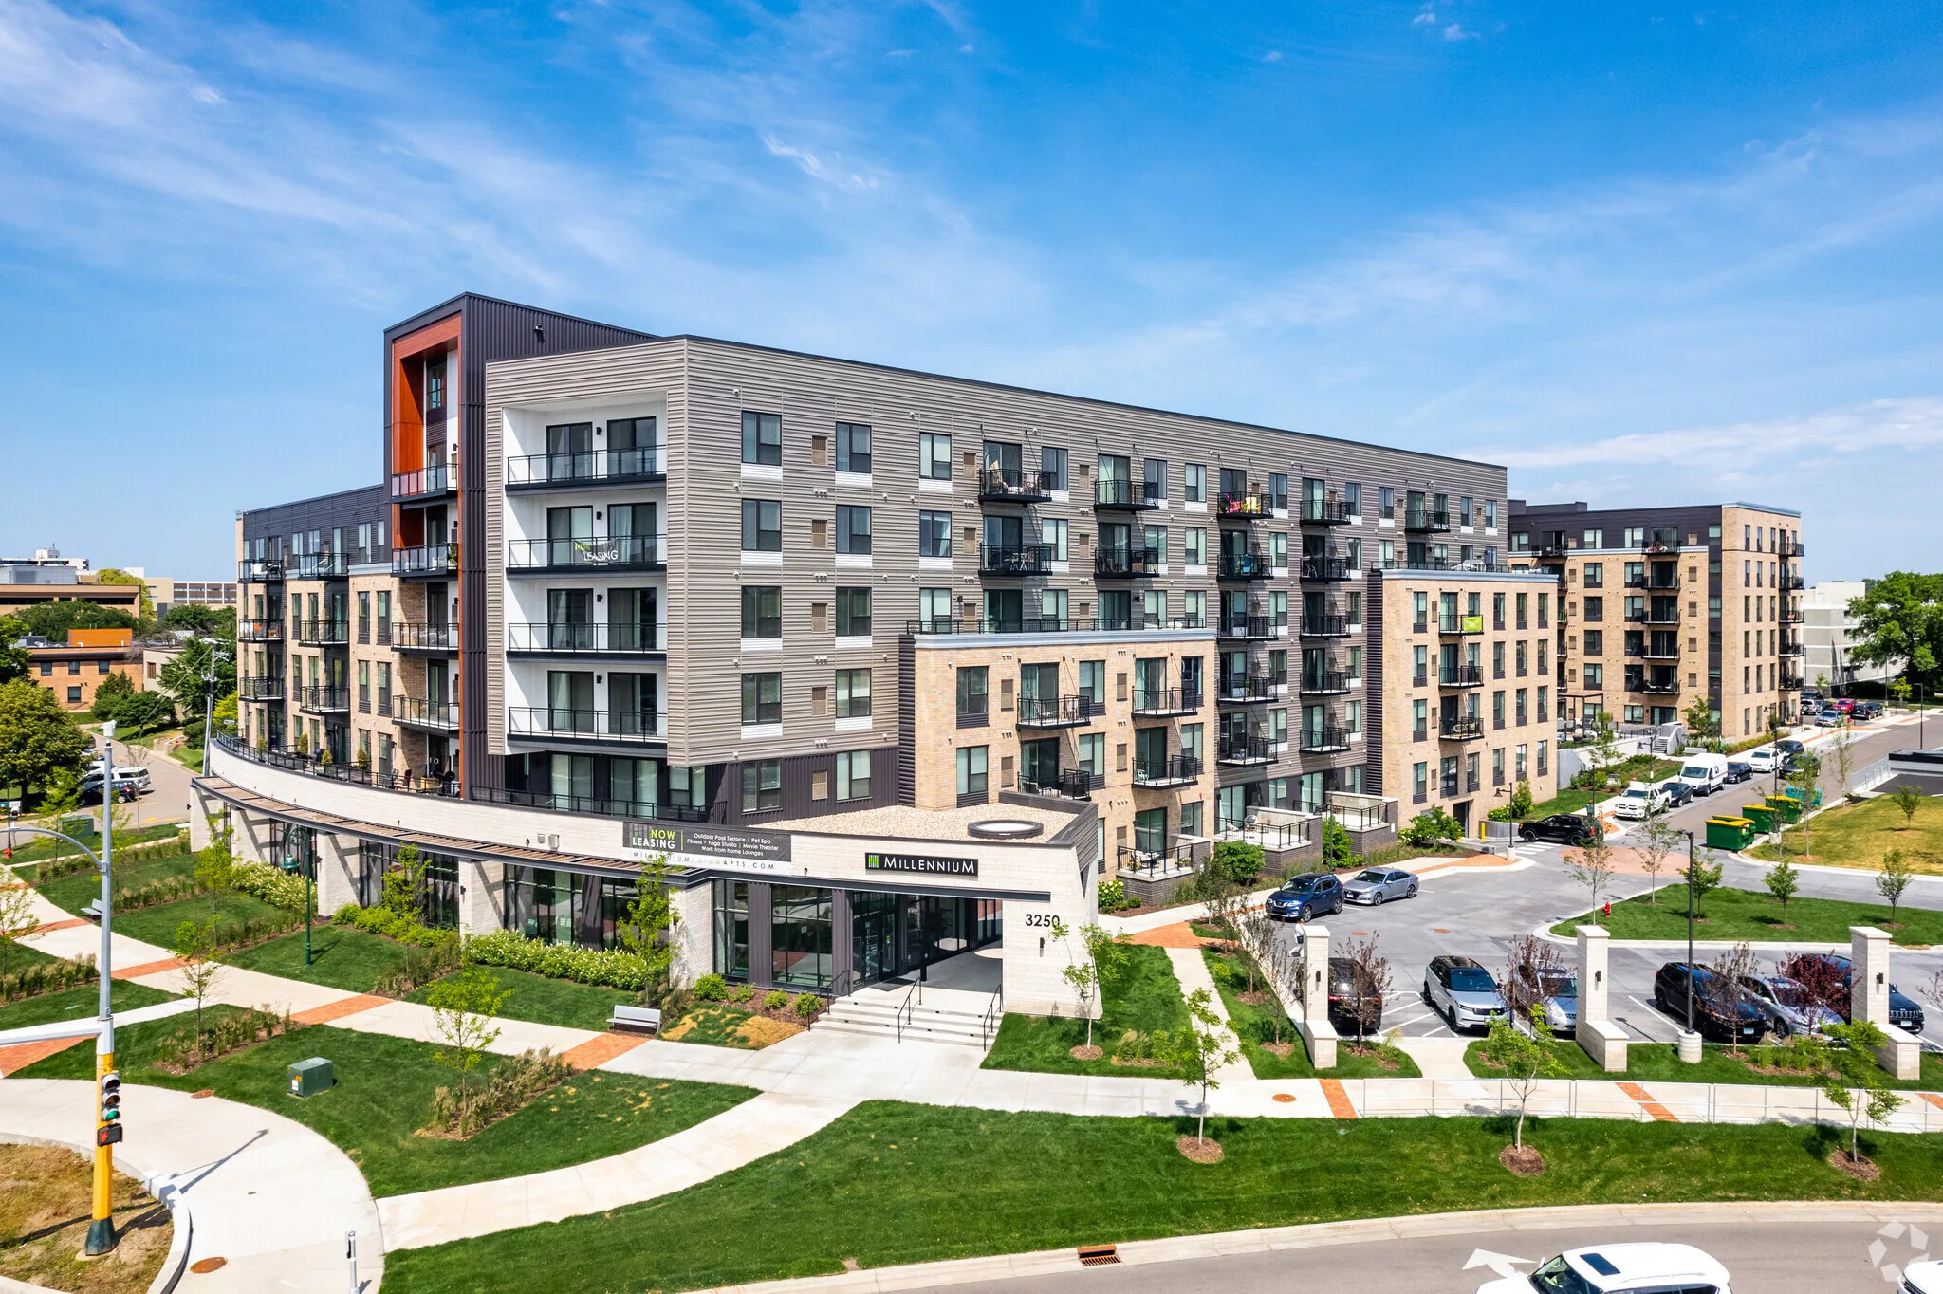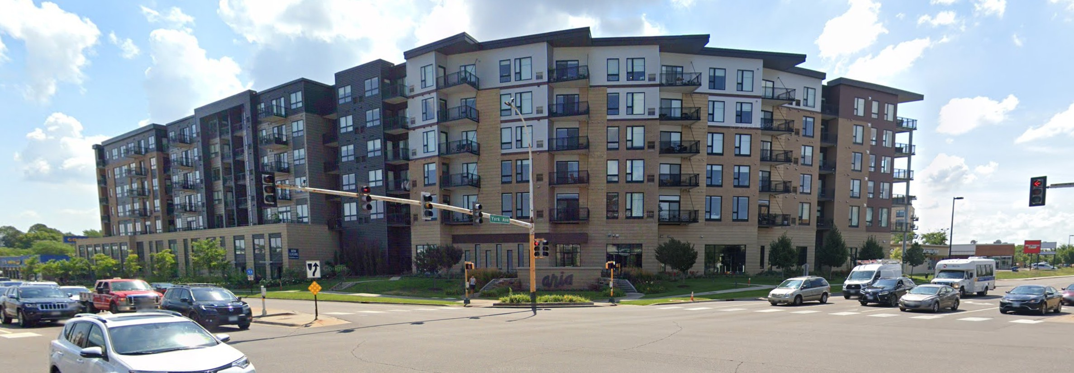

Brooklyn Boulevard
North
LRT STATION
West Broadway
STATION AREA OVERVIEW : PHASE 1 INFIL DEVELOPMENT

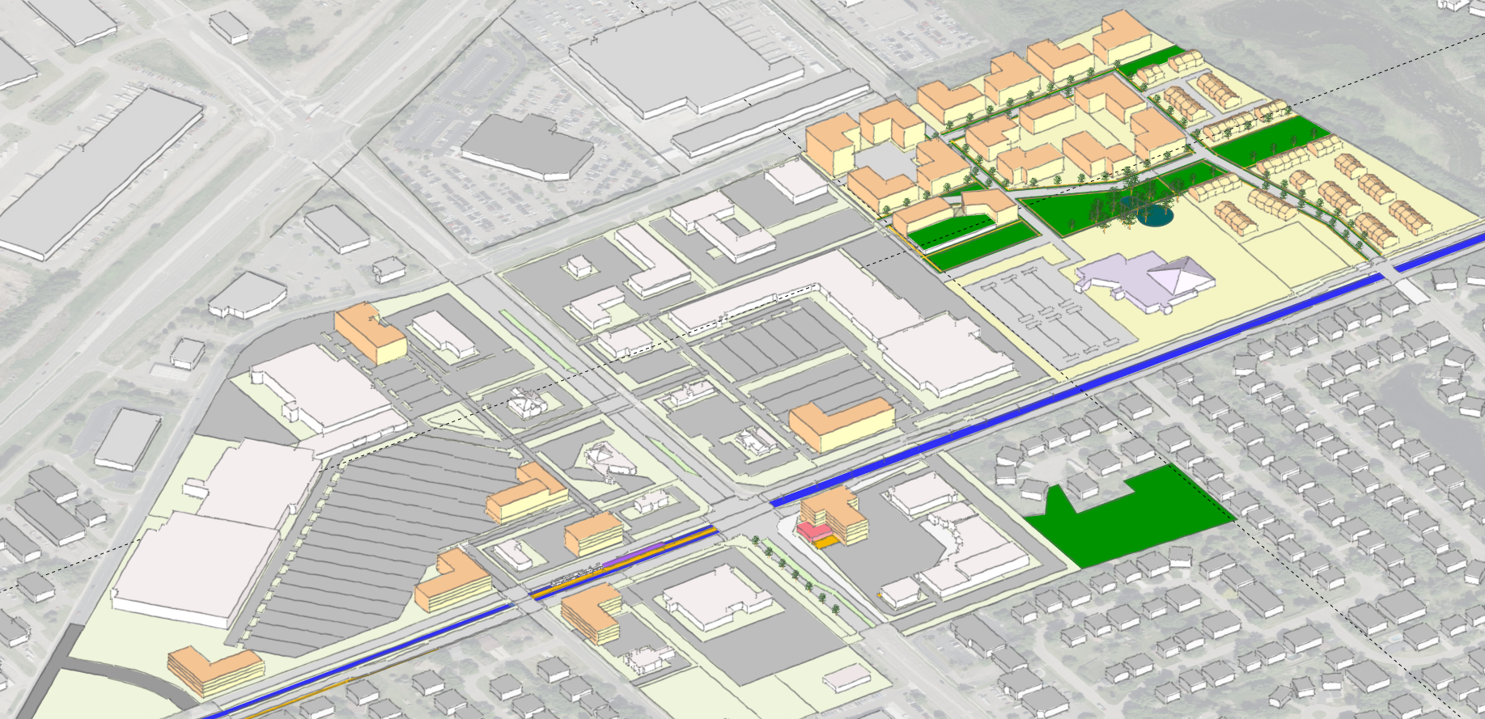
Menards

Revive
Brooklyn Boulevard
West Broadway
Church

Star
Dragon

Target
Northwinds Plaza
Park Lawn Park

Target
Brooklyn Boulevard
North
LRT STATION
West Broadway
STATION AREA OVERVIEW

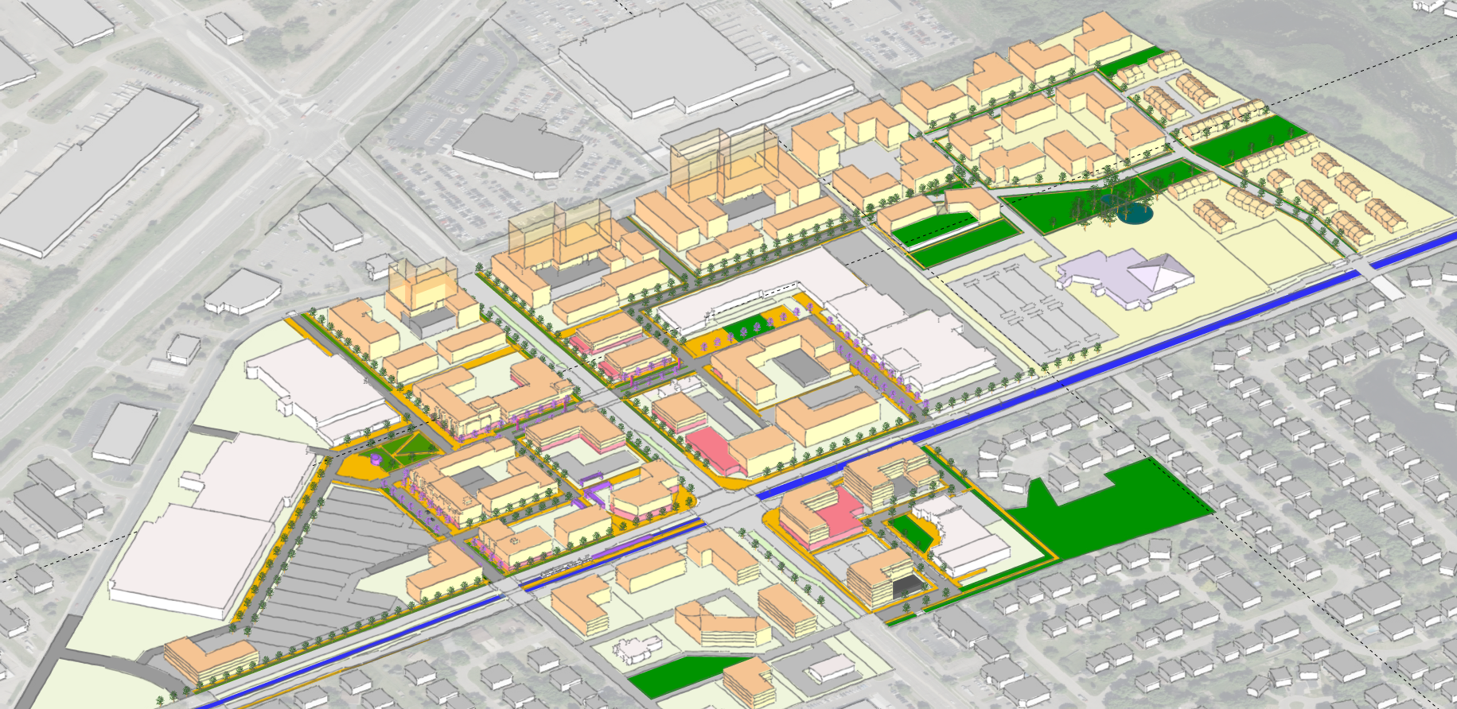
Menards
Mobility
Hub

Revive
Brooklyn Boulevard
West Broadway
Church

Star
Dragon

Park Lawn Park
Northwinds Plaza

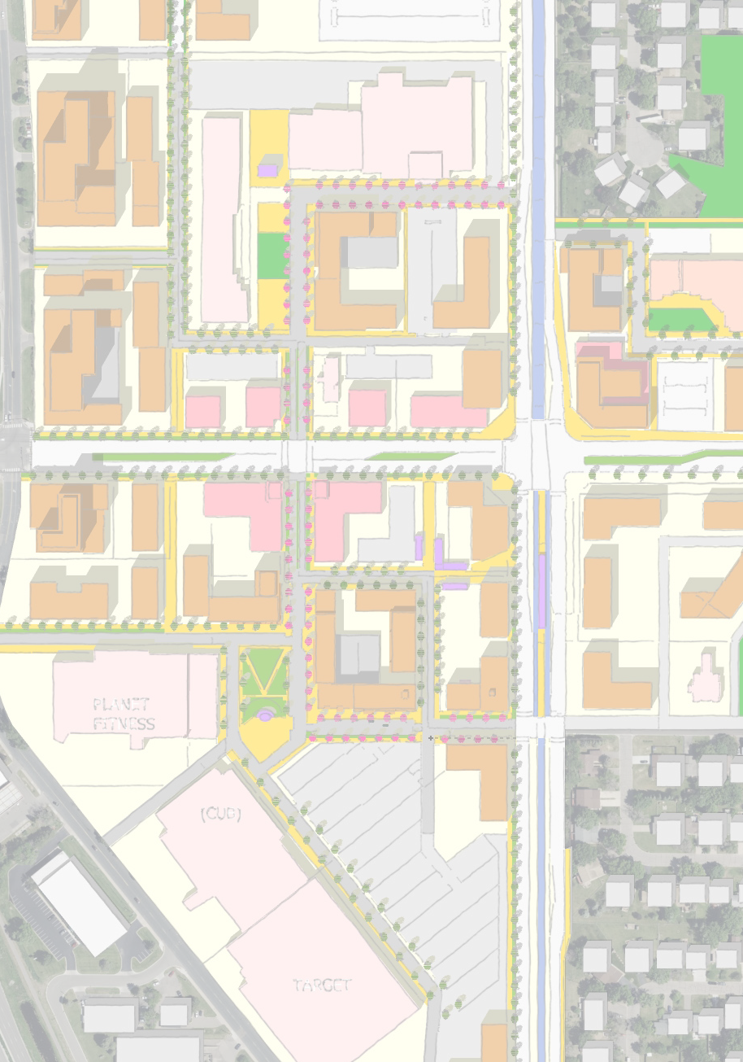
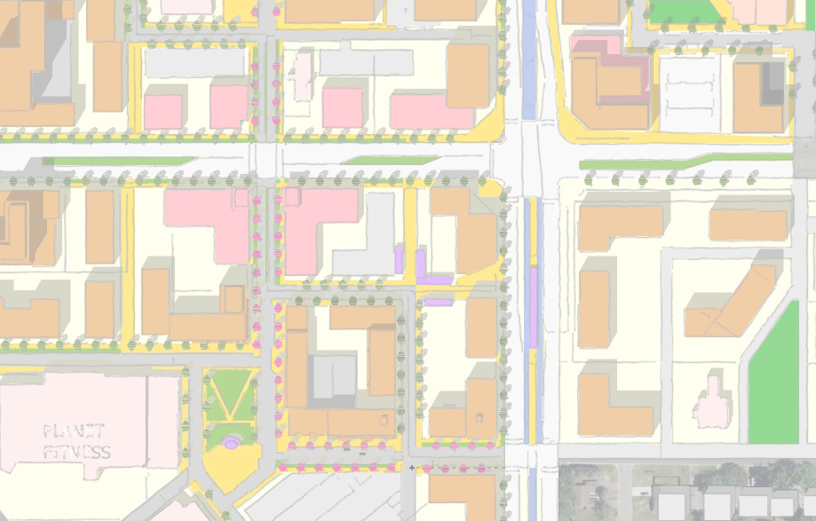
on Star
Drag
Northwinds
Brooklyn Boulevard
mobility
Hub
Planet Fitness
Pkg
Pkg
Target
Brooklyn Boulevard
West Broadway
W. Broadway
STATION AREA OVERVIEW : APPROACH
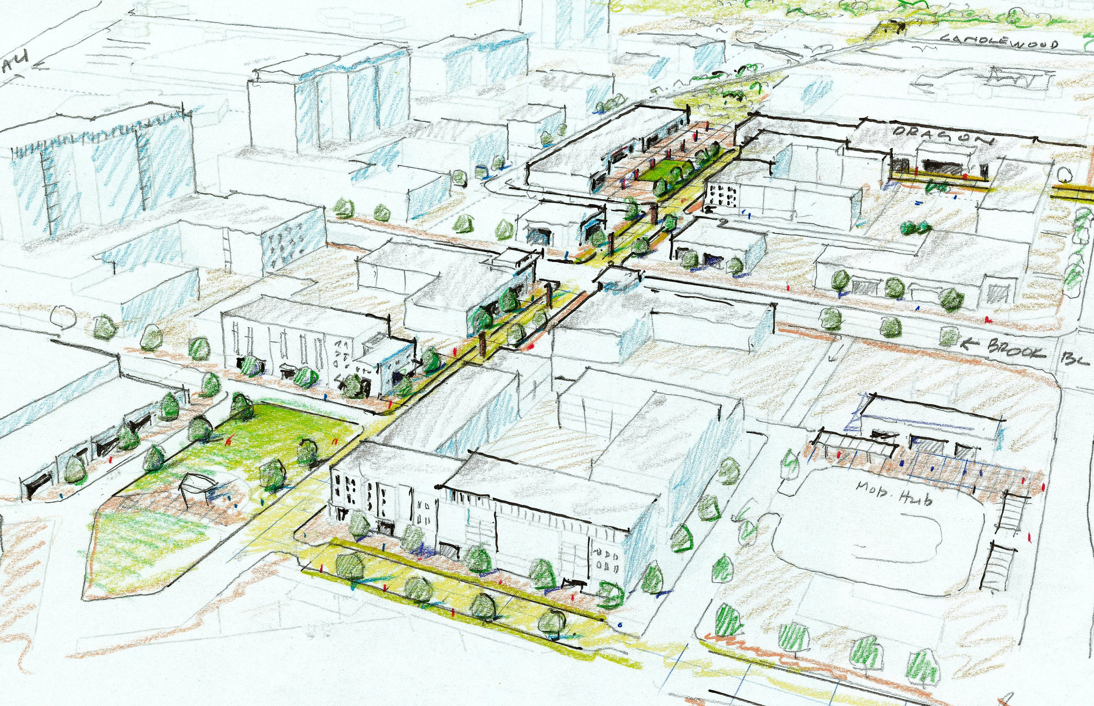
Dragon Star
Dragon Star
Pkg

Pedestrian Oriented Retail Street from Anchor to Anchor; enhanced with public spaces at the ends

Northwinds Plaza Site

Alternative 1
NORTHWINDS PLAZA SITE
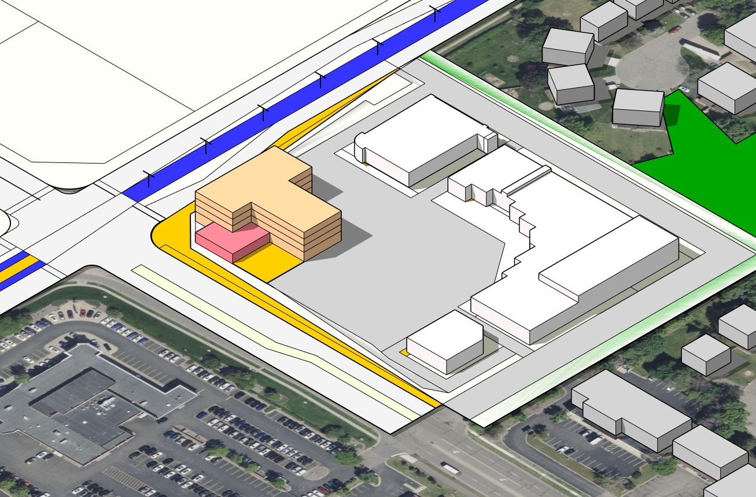
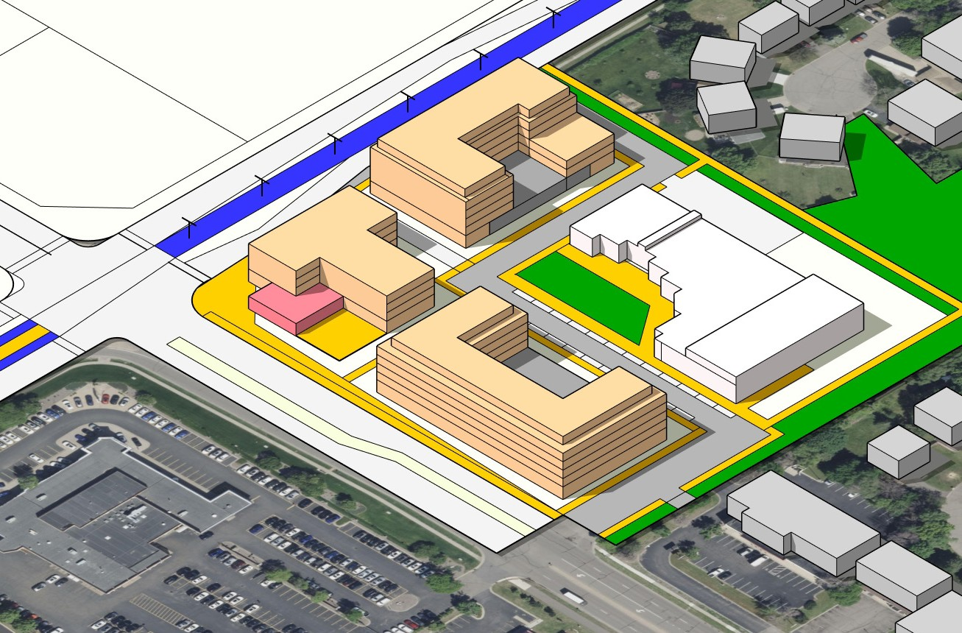
Phase 1: Build on parking lot Phase 2: Build on CVS and Liquor Store
Alternative 2
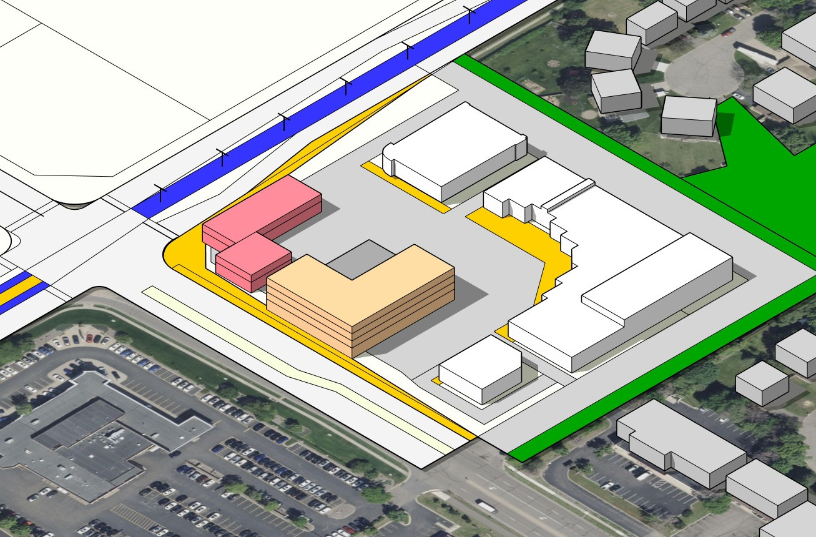
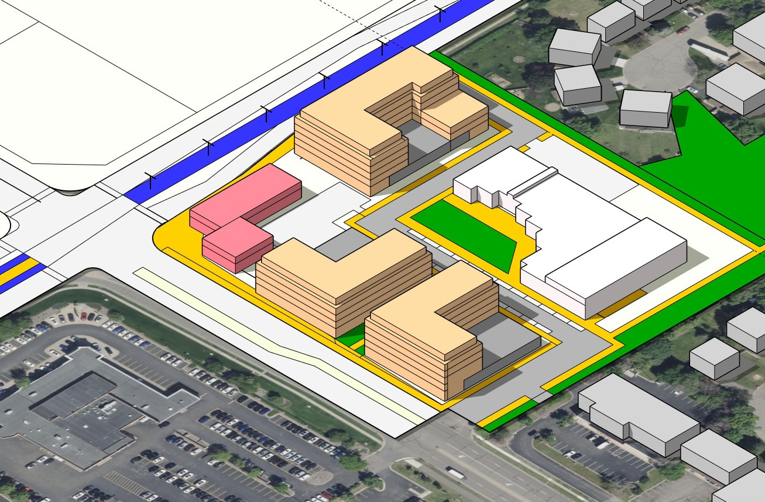
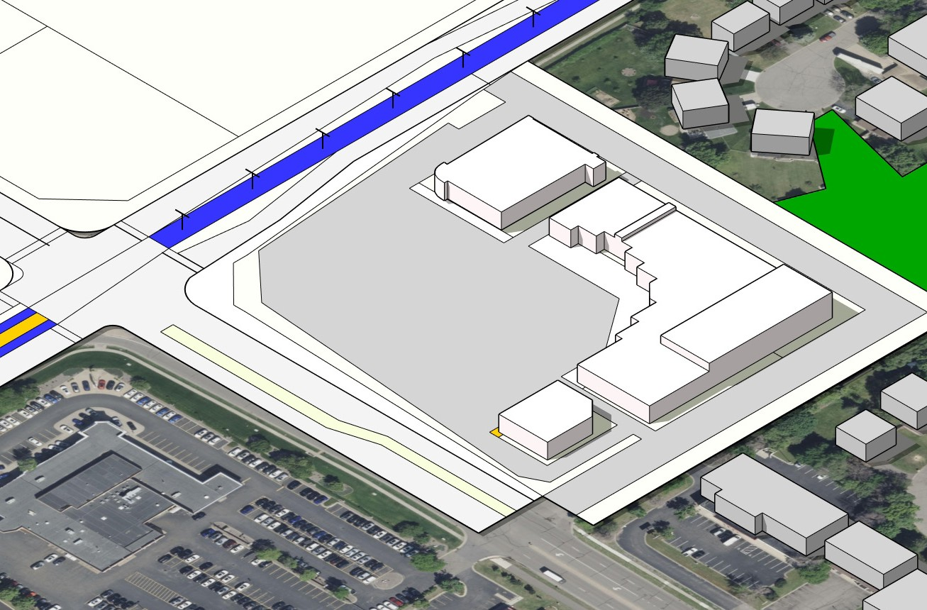
Phase 1: Build on parking lot Phase 2: Build on CVS and Liquor Store
CVS
(vacant)
Small Businesss Center
Liquor
West Broadway
Alternative 3
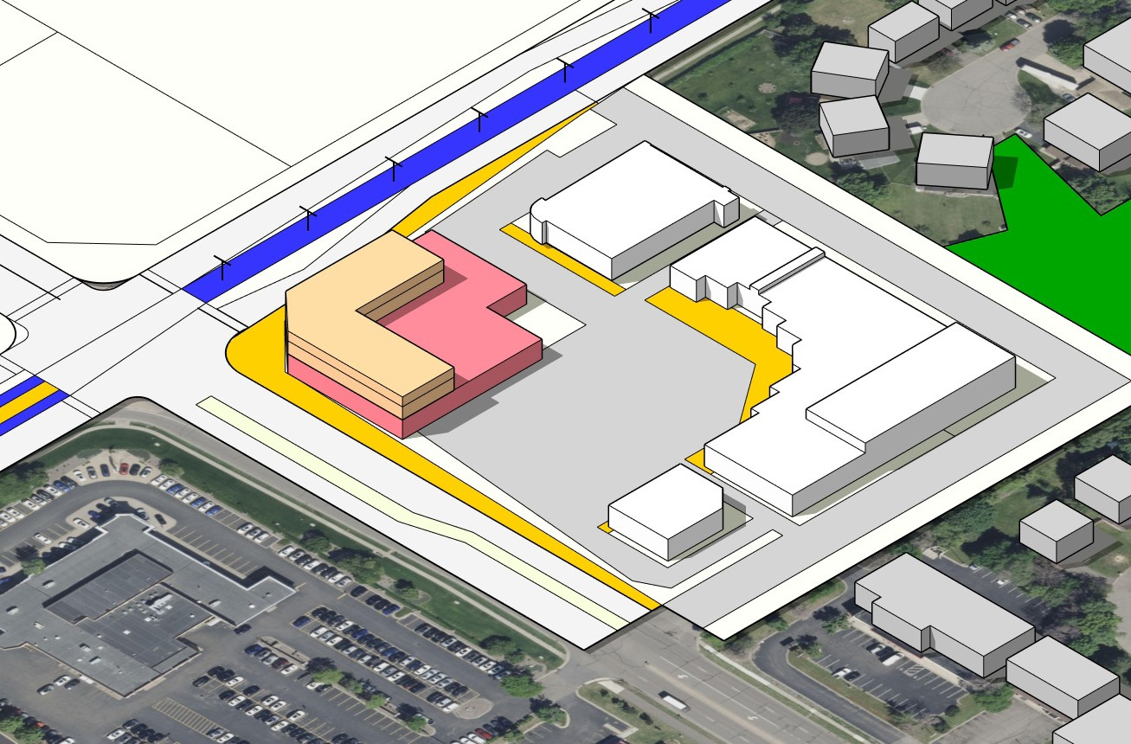
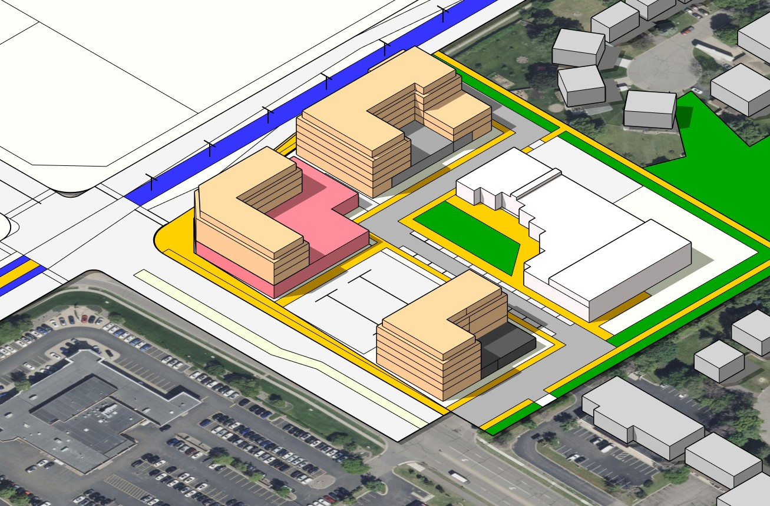
Phase 1: Build on parking lot Phase 2: Build on CVS and Liquor Store
Residential

Commercial
Brooklyn Blvd

NORTHWINDS PLAZA

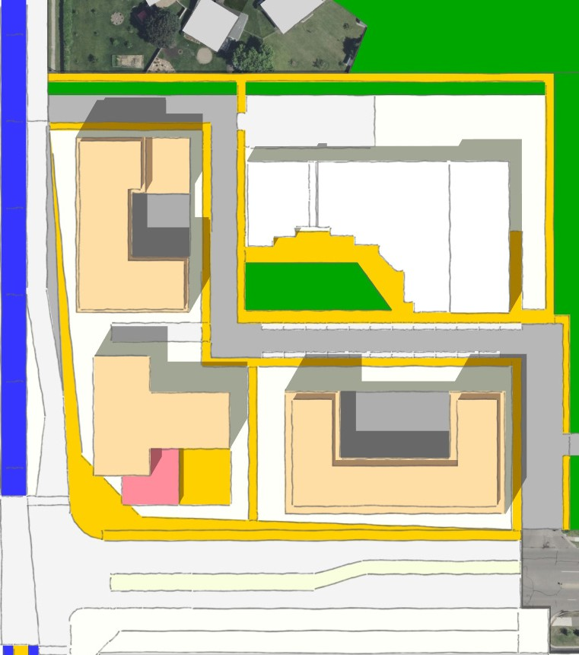
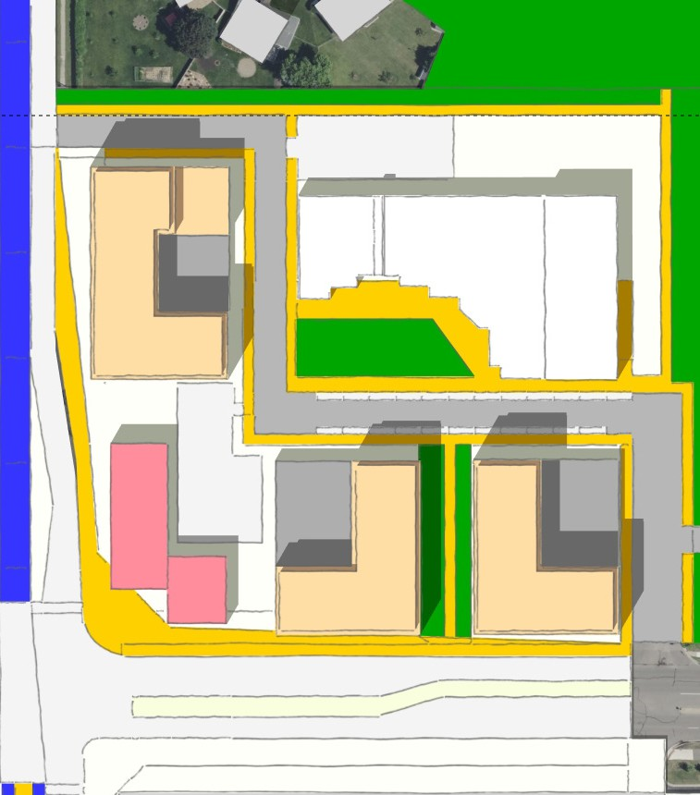
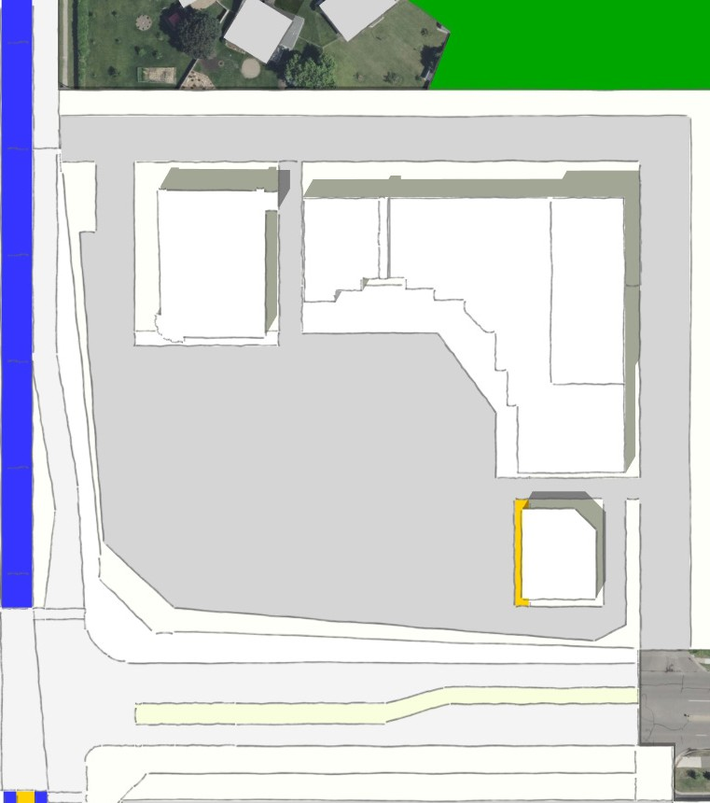
Phase 1: Build on parking lot
Park Lawn Park
B
D
Small Business
Center
A
C
Brooklyn Blvd
Park Lawn Park
B
E
Small Business
Center
A
C
D
Brooklyn Blvd
Park Lawn Park
CVS
(vacant)
Small Businesss Center
PHASE 2
PHASE 1
PHASE 2
Liquor
Brooklyn Blvd
Phase 2: Build on CVS and Liquor Store
Alternative 1: Alternative 2:
Alternative 3:

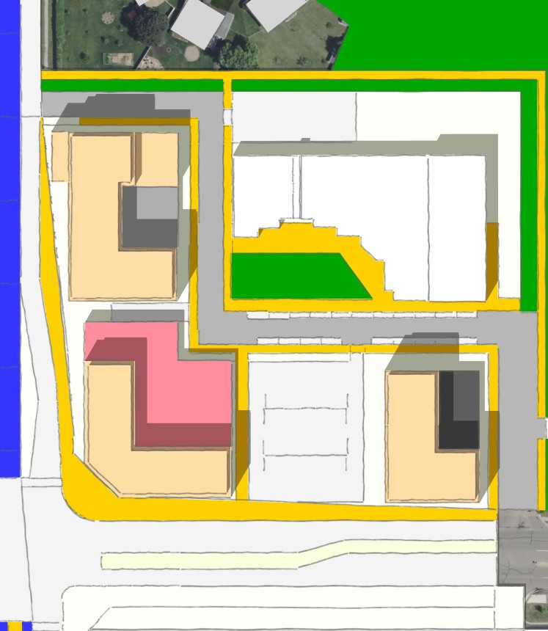
Park Lawn Park
B
D
Small Business Center
A
Anchor Grocer
C
Brooklyn Blvd
West Broadway
West Broadway
West Broadway
West Broadway
Bldg | Estimated housing units | Estimated retail space
 | 0 units | 66,000 sf

Bldg | Estimated housing units | Estimated retail space
A | 60 units | 5,000 sf retail
B | 100 units | 5,000 sf retail
C | 120 units | 5,000 sf retail
D | n/a | 30,000 sf retail

Bldg | Estimated housing units | Estimated retail space
A |  | 20,000 sf retail
B | 100 units | 5,000 sf retail
C | 50 units | n/a
D | 50 units | n/a
E | n/a | 30,000 sf retail

Bldg | Estimated housing units | Estimated retail space
A | 50 units | 30,000 sf retail
B | 100 units | 5,000 sf rtl
C | 50 units | 5,000 sf retail
D | n/a | 30,000 sf retail

Corridor Approach

THE CORRIDOR

Station Area

Brooklyn Boulevard

Georgia Site

Redeemer Church Site

Village Area

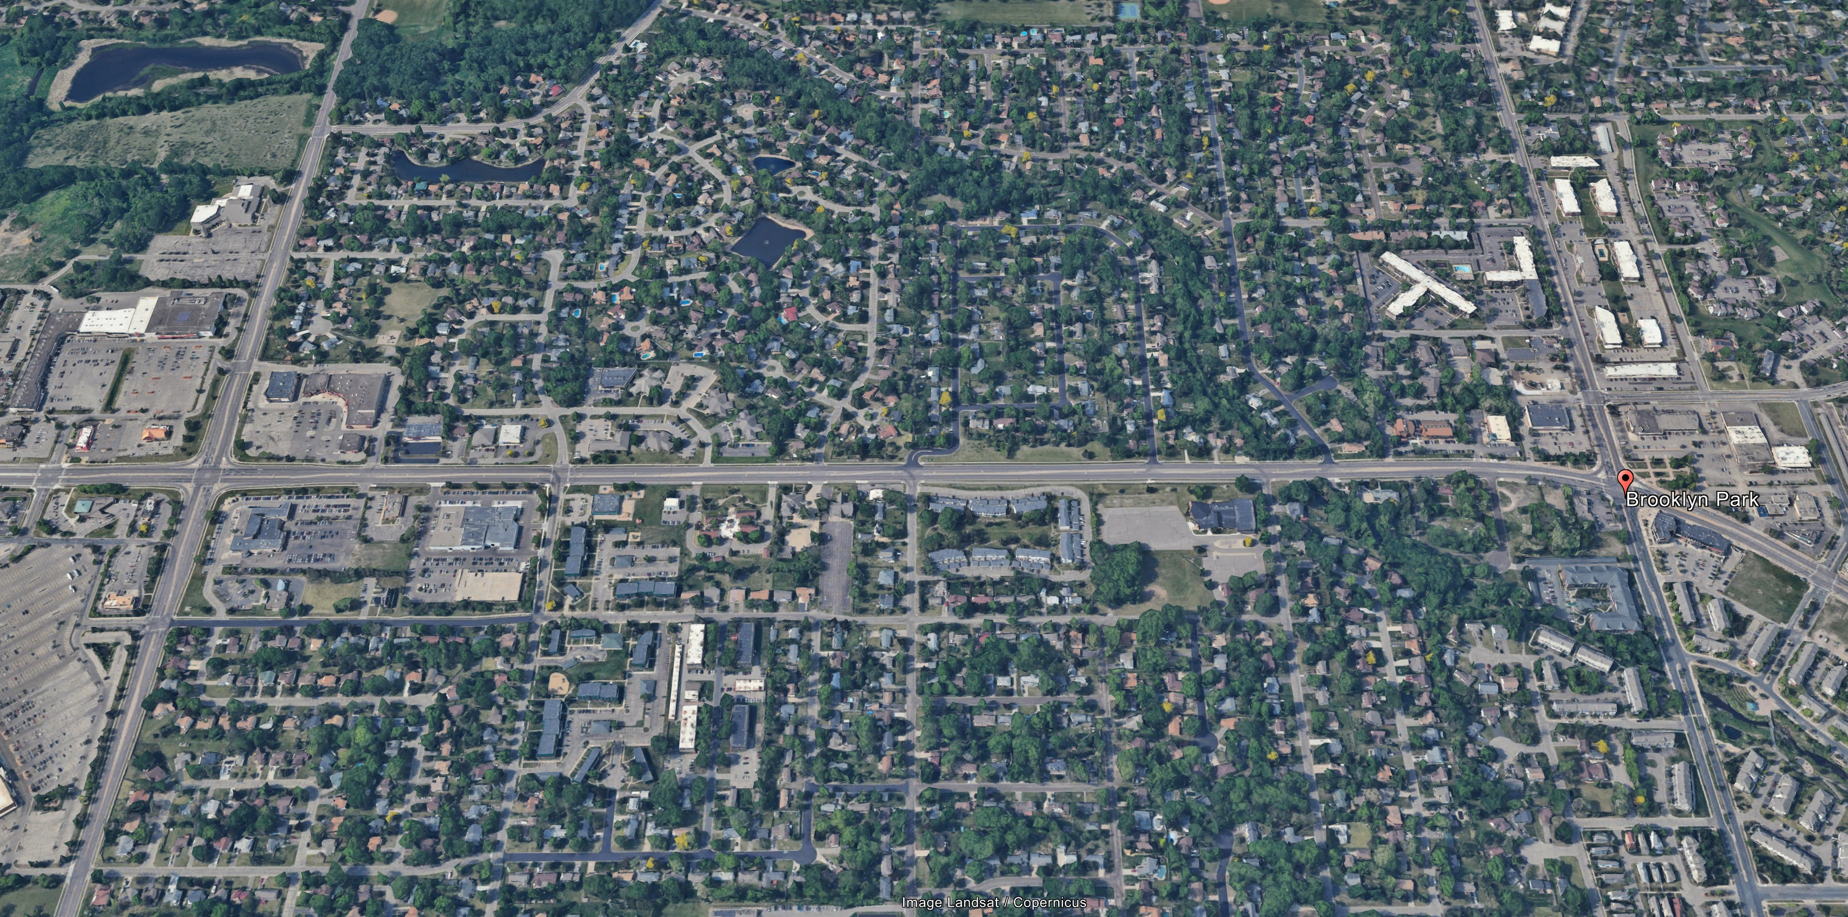

76th Ave N

Georgia Site

Brooklyn Blvd
Georgia Ave
GEORGIA SITE
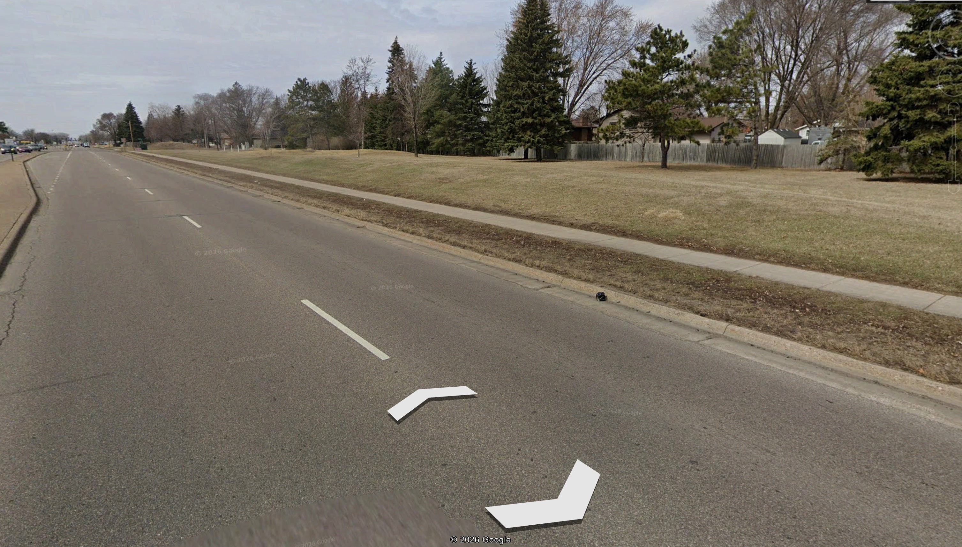

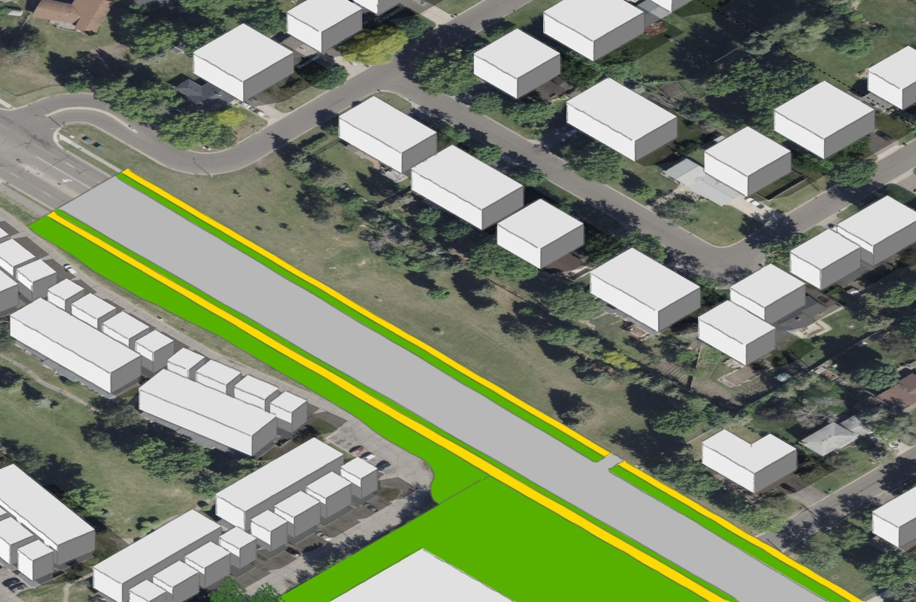
City Owned, recommend transferring to EDA for redevelopment 115 feet deep
Primary access off Georgia Ave
May require secondary access onto Brooklyn Boulevard Would require rezoning for housing redevelopment

GEORGIA SITE
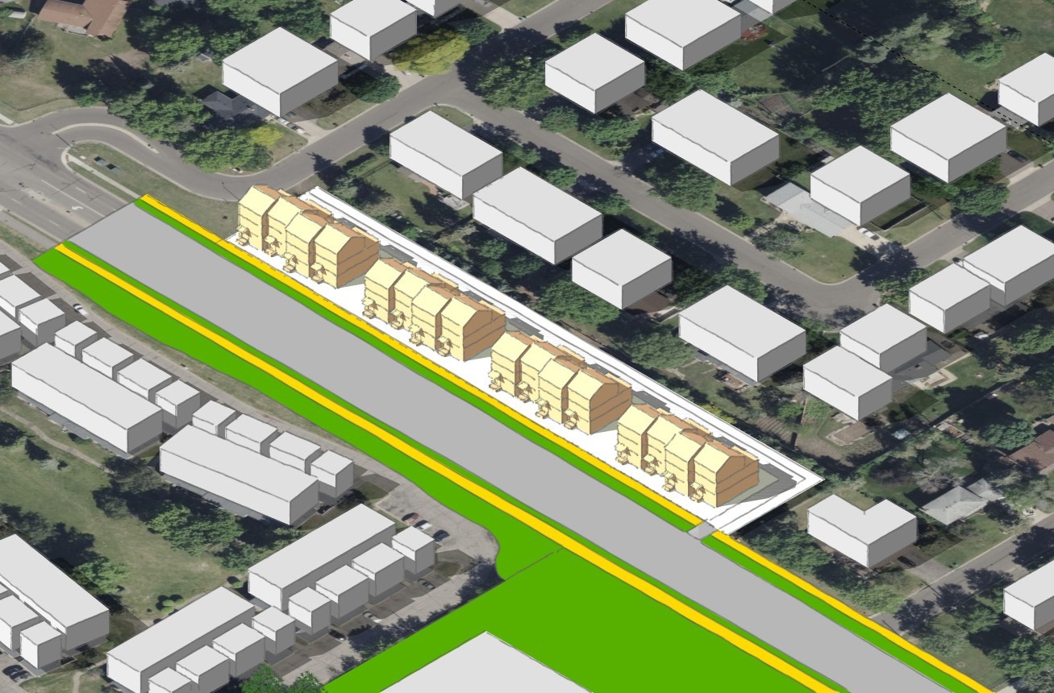
Townhomes
Right In Only
Georgia Ave

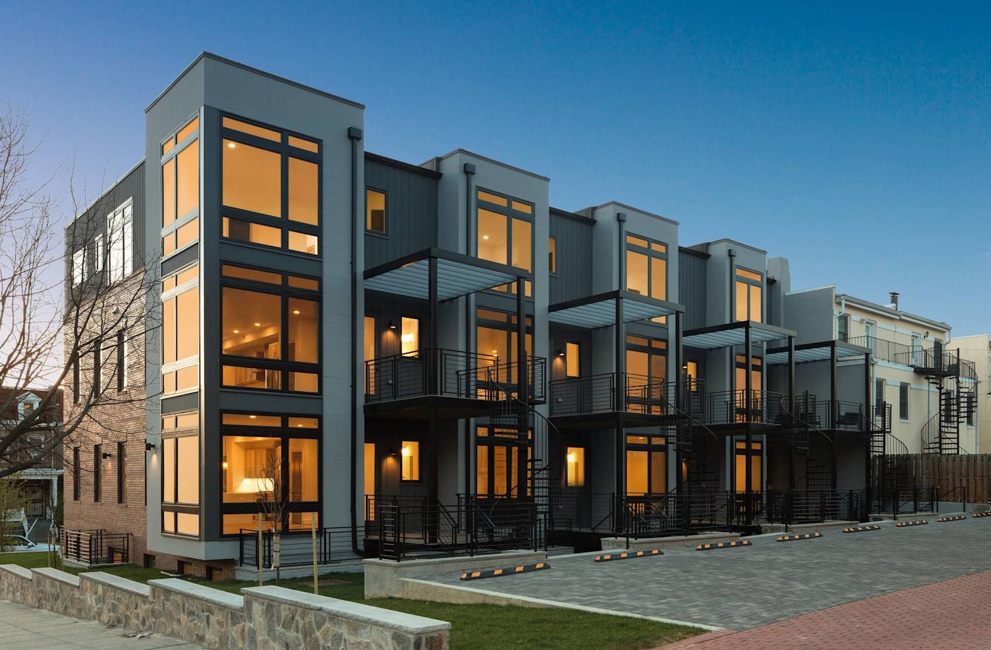
16 townhouse units
Brooklyn Blvd
rear loaded (garages in the back) stoop or porch frontages
secondary access from Brooklyn Boulevard

Redeemer Church Site

Brooklyn Blvd
REDEEMER CHURCH SITE

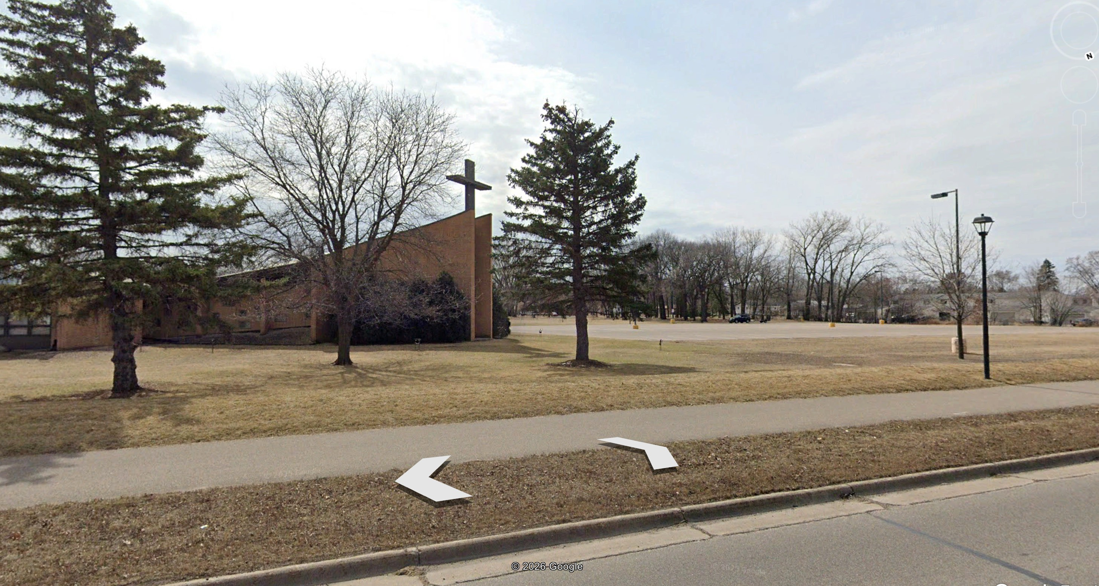

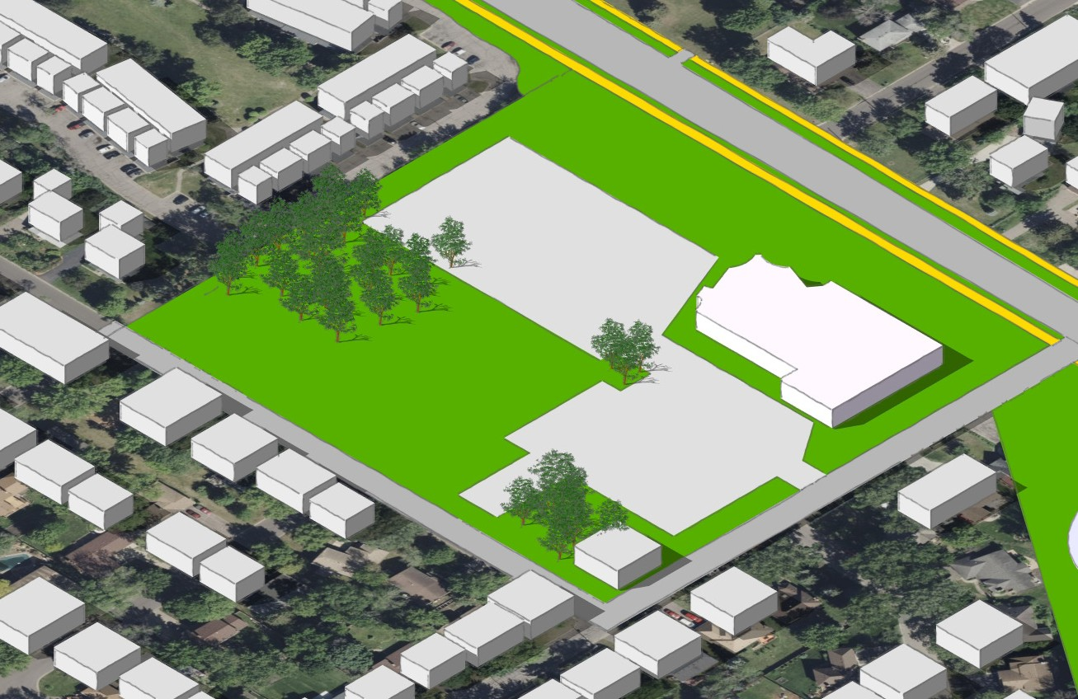
Privately owned
Approximately 5 acres of developable land Access on Brooklyn Blvd and 76th Ave
Would require rezoning for housing development

Brooklyn Blvd
REDEEMER CHURCH SITE

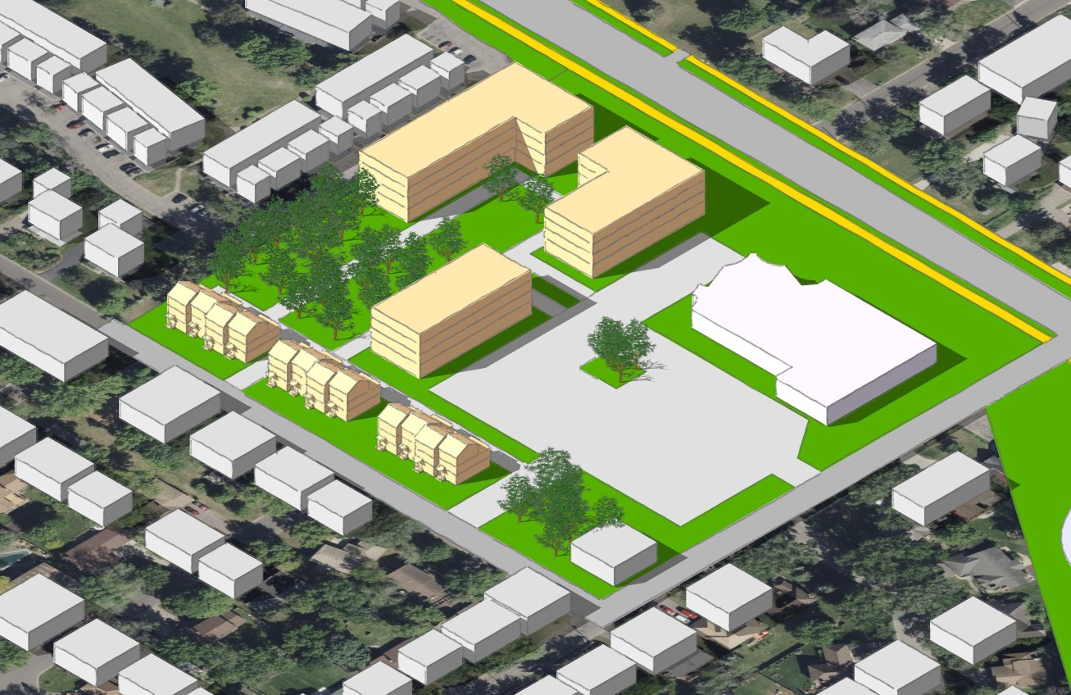
Preserved tree stand 12 townhouse units
rear loaded (garages in the back) stoop or porch frontages
150 apartments

Village Area Updates

VILLAGE DEVELOPMENT CONCEPT ALTERNATIVE 1 & 2

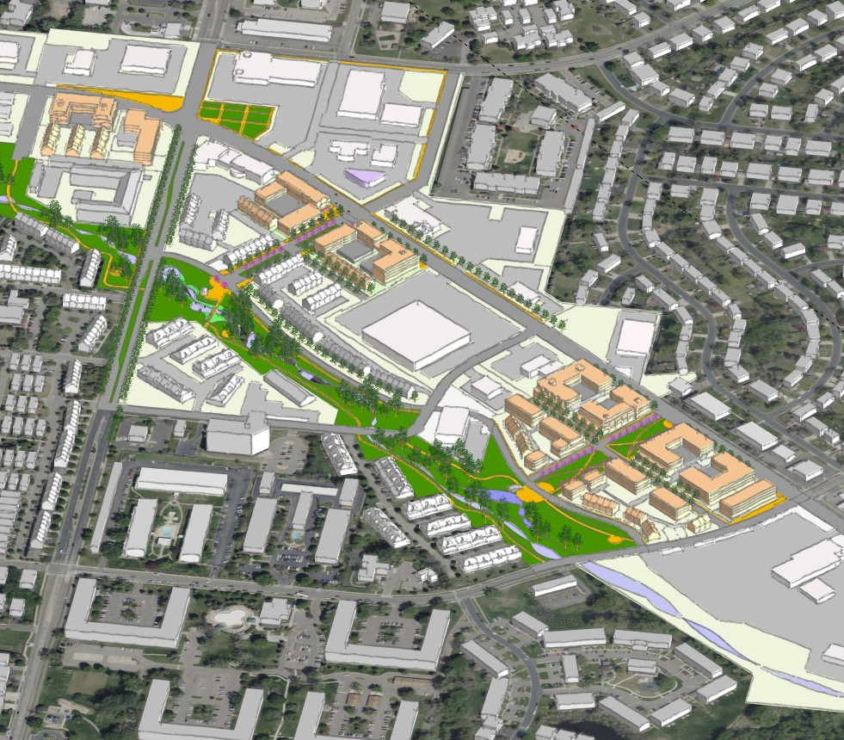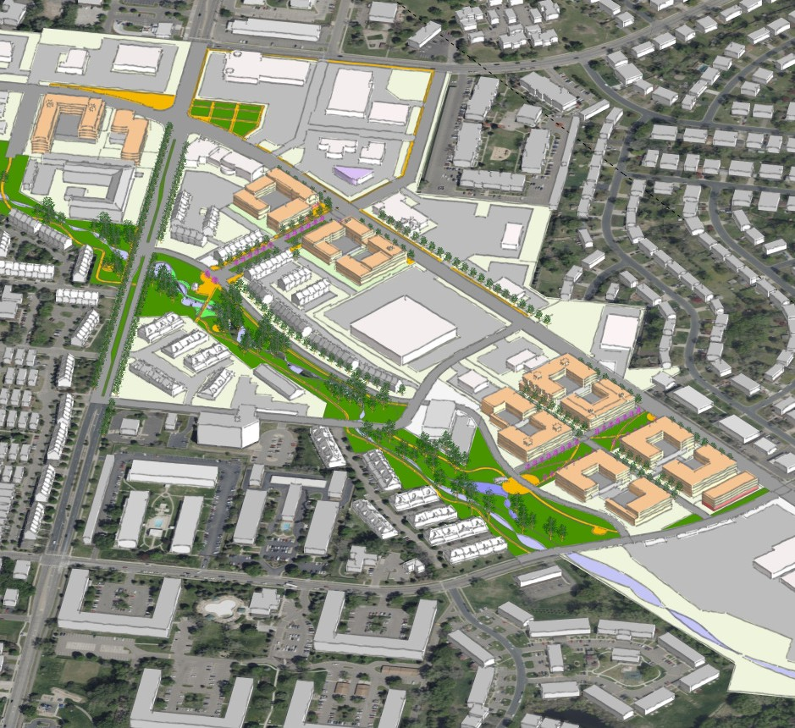

Alt 1
Ownership along the Creek Apartments along the Corridor
Alt 2
Apartments along Creek and Corridor

ALTERNATIVE 3
VILLAGE DEVELOPMENT CONCEPT UPDATE
Welcome Ave
Horizontal Mixed Use

Horizontal Mixed Use

Horizontal Mixed Use

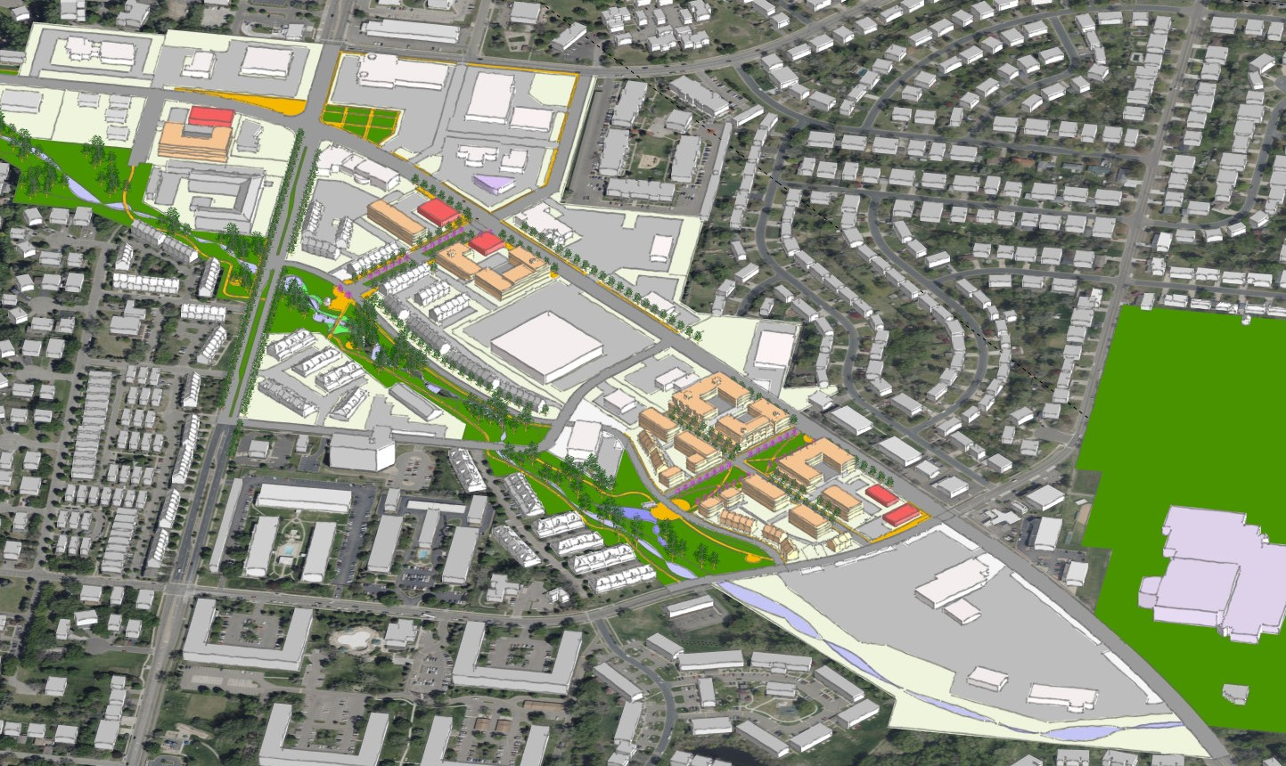
Residential
Regent St
Brooklyn Blvd
Zane Ave

Horizontal mixed use

VILLAGE : POTENTIAL FULL BUILD OUT

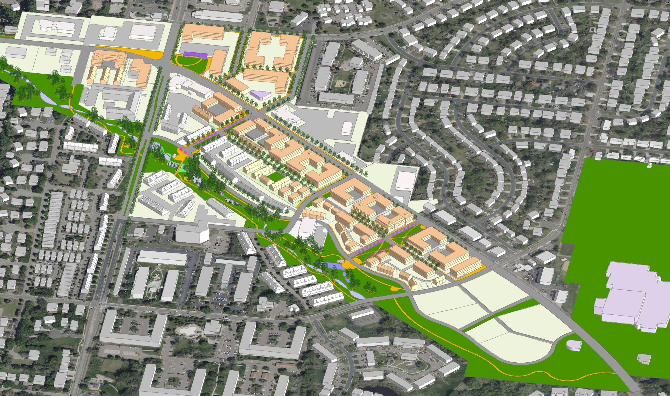

Overall Corridor

OVERALL CORRIDOR: EXISTING

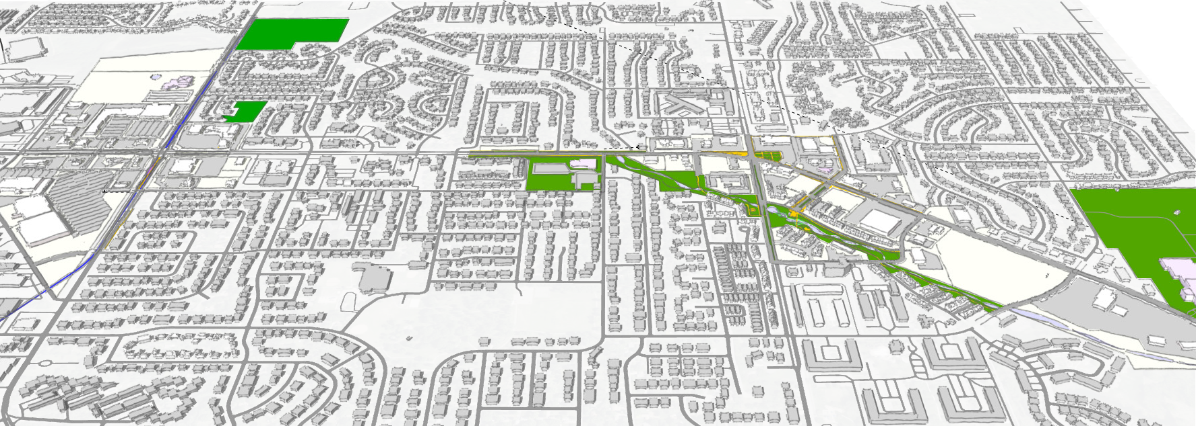

OVERALL CORRIDOR: POTENTIAL FULL BUILD OUT

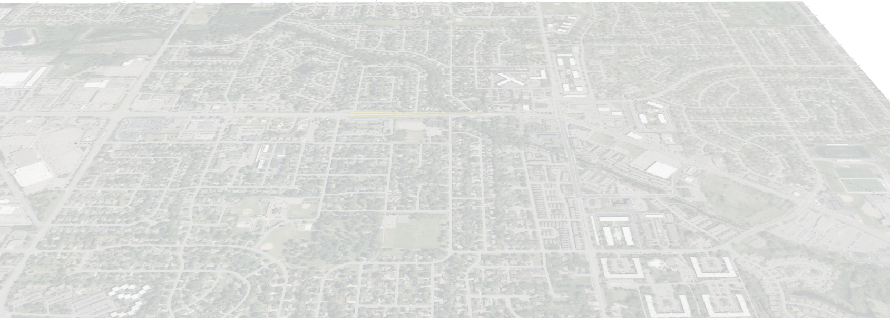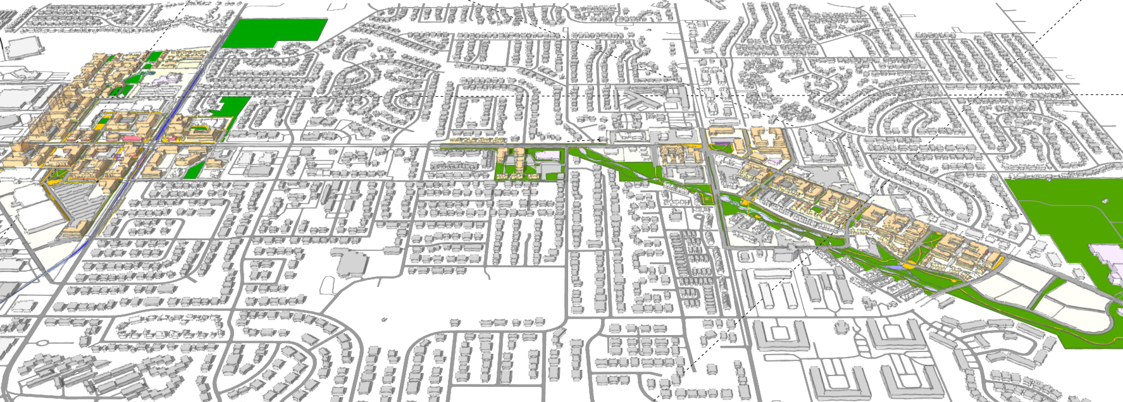

Next Steps

Next Steps
- Market study engagement (ongoing)
- Property owner outreach (ongoing)
- Focus groups in April
- Joint City Council and Planning Commission meeting in late April, early May 2026
- Open house in May

- Plan adoption in early summer 2026

- Sign up for the listserv and encourage others!

DEVELOPMENT FINANCIAL EXERCISE

$172,500/yr

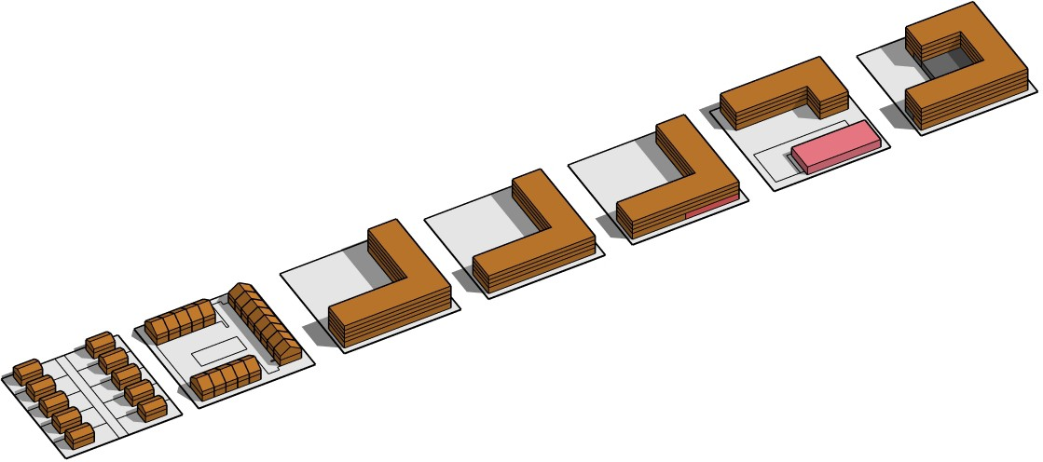
$72,750/yr
FINDINGS:
1. Higher residential density consistently performs well.
2. LIHTC projects reduce benefit because their tax
classification lowers the return from added density
3. Small amounts of commercial space have minimal
impact. Even with higher tax rates, the scale is too small
to affect the outcomes
4. Horizontal mixed use brings in less revenue unless it’s
paired with much higher residential density to offset the
gap.

local revenues on a typical 1.5 Acre Site:

$12,000/yr

$30,000/yr

- Single Family and Duplex Homes

$27,000/yr

- Townhomes and Middle housing

$120,000/yr

- LIHTC
Apartment
ONGOING FINANCIAL ANALYSIS:

1. Details by development type including total square footage, density, and estimated housing units and retail space.
2. Estimated City tax revenue by development type.
3. Estimated financial gap by development type.

4. Summary of findings.
$117,750/yr

- Market Rate Apartment

6. Horizontal Mixed Use Market Rate Building
- Vertical Mixed Use Market Rate Building

7. High Density Market Rate Apartment

Brooklyn Blvd Corridor Plan EDA Meeting , March 16th, 2026
41

Precedents

Eden Center, Falls Church, VA
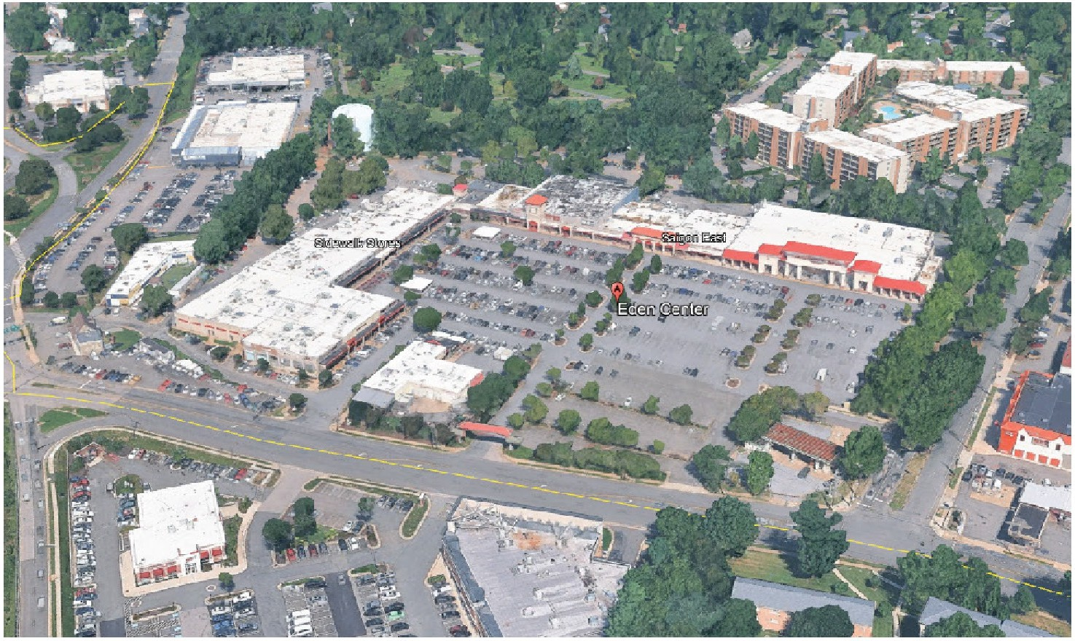

Huntersville, NC
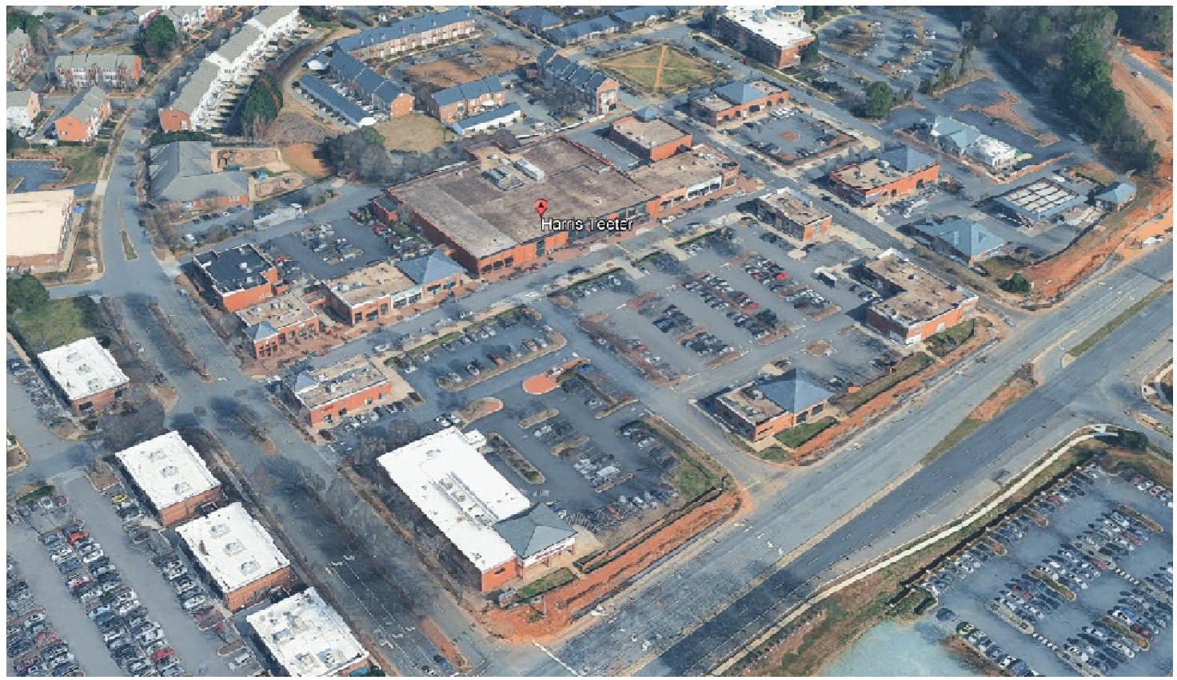

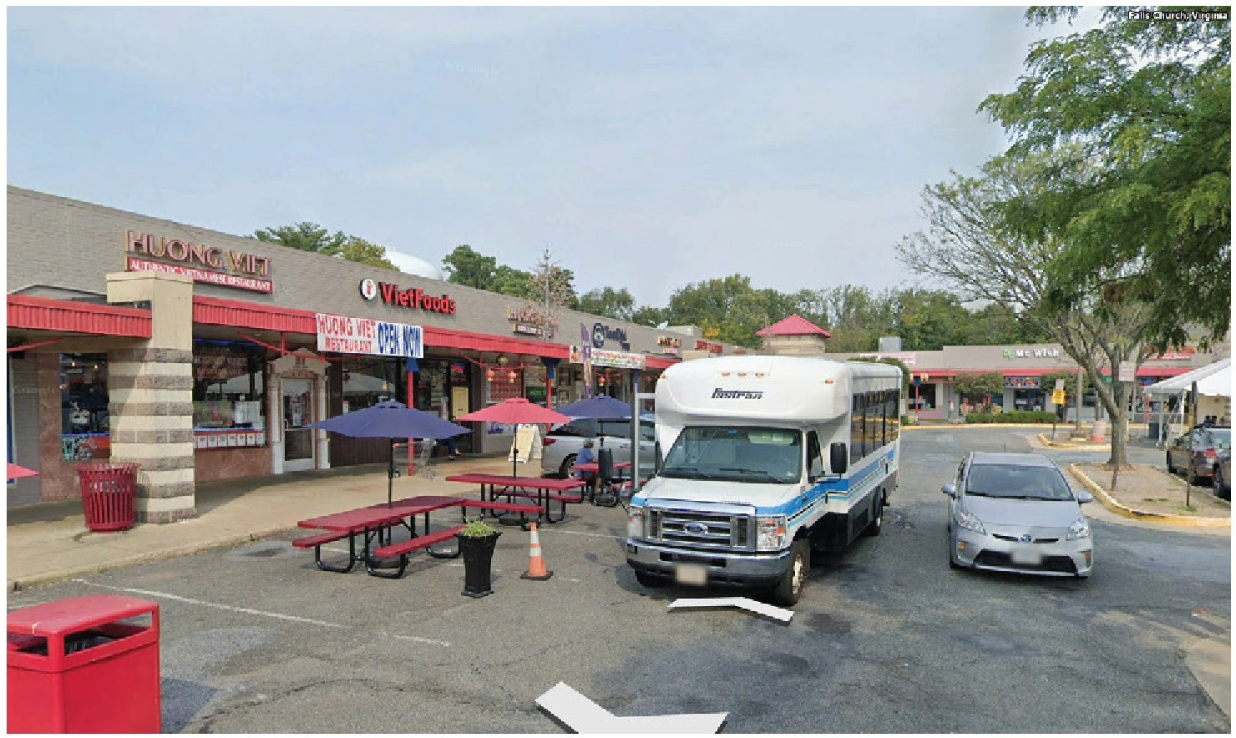
Transit and tactical urbanism

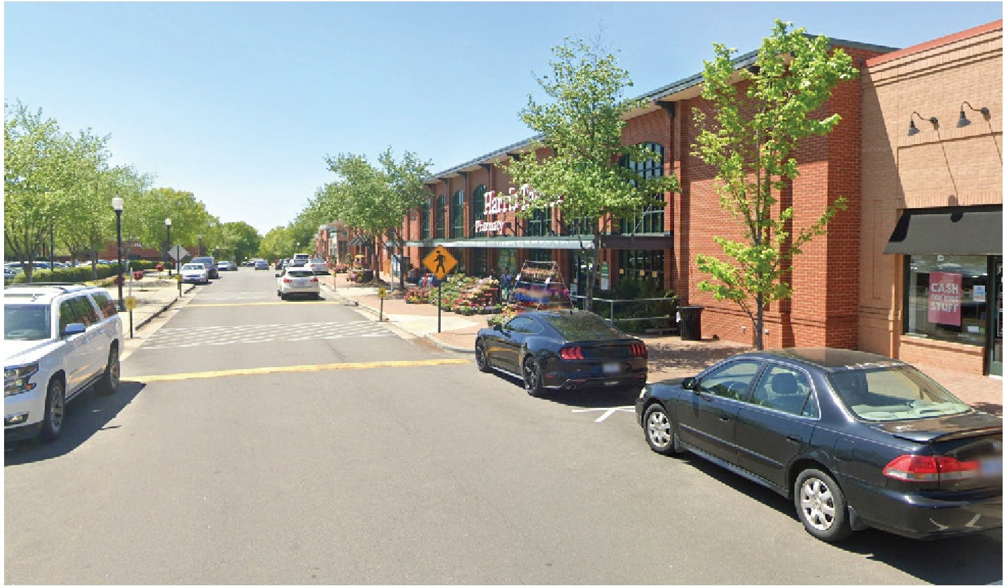
Paralell parking and a real street on front of in line stores

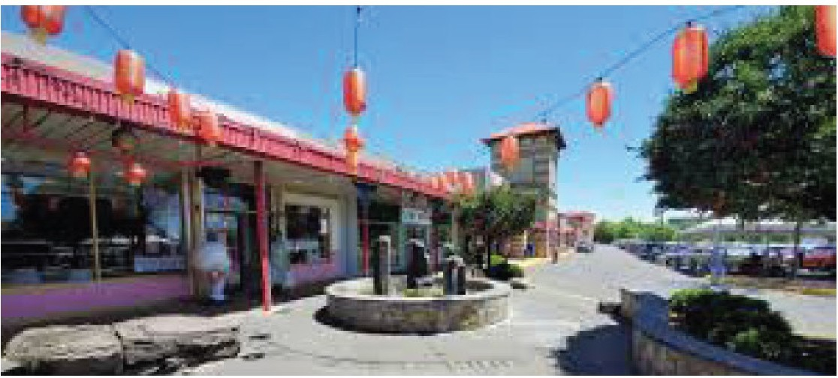
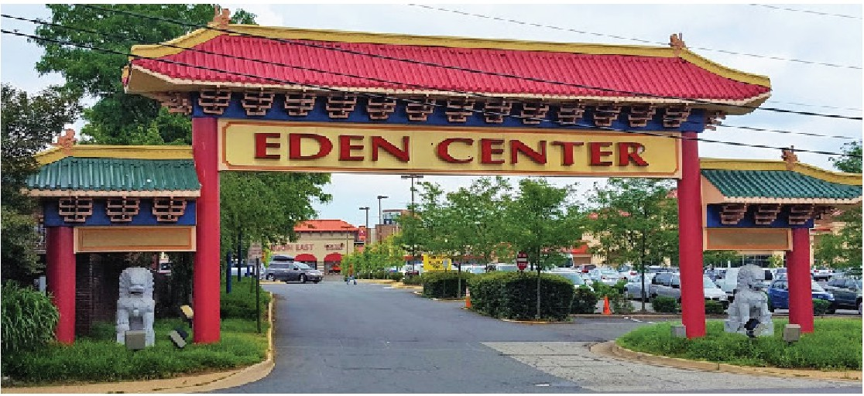

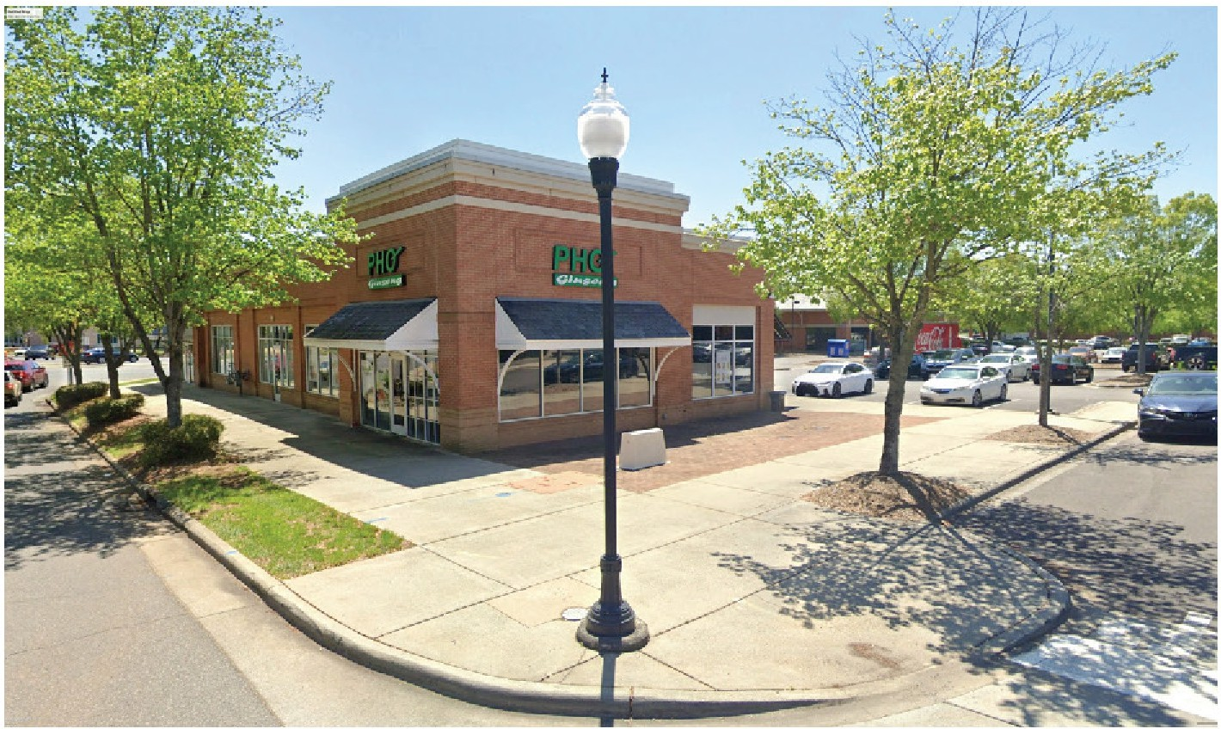
Out lot buildings with two fronts

Placemaking and cultural identity

Precedents

La Placito Cinco, los Angeles, CA
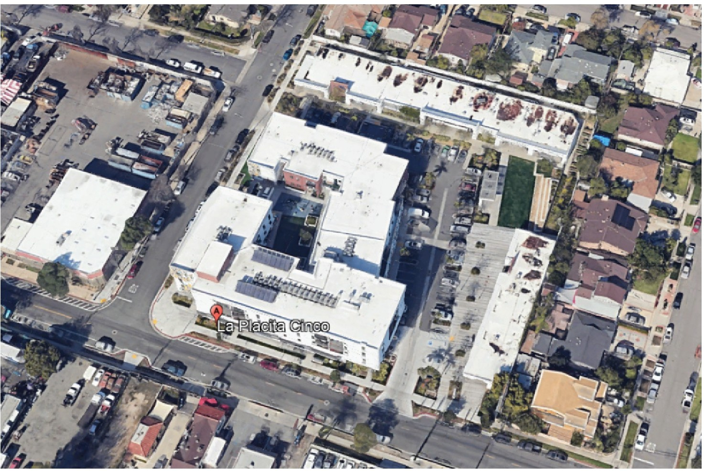
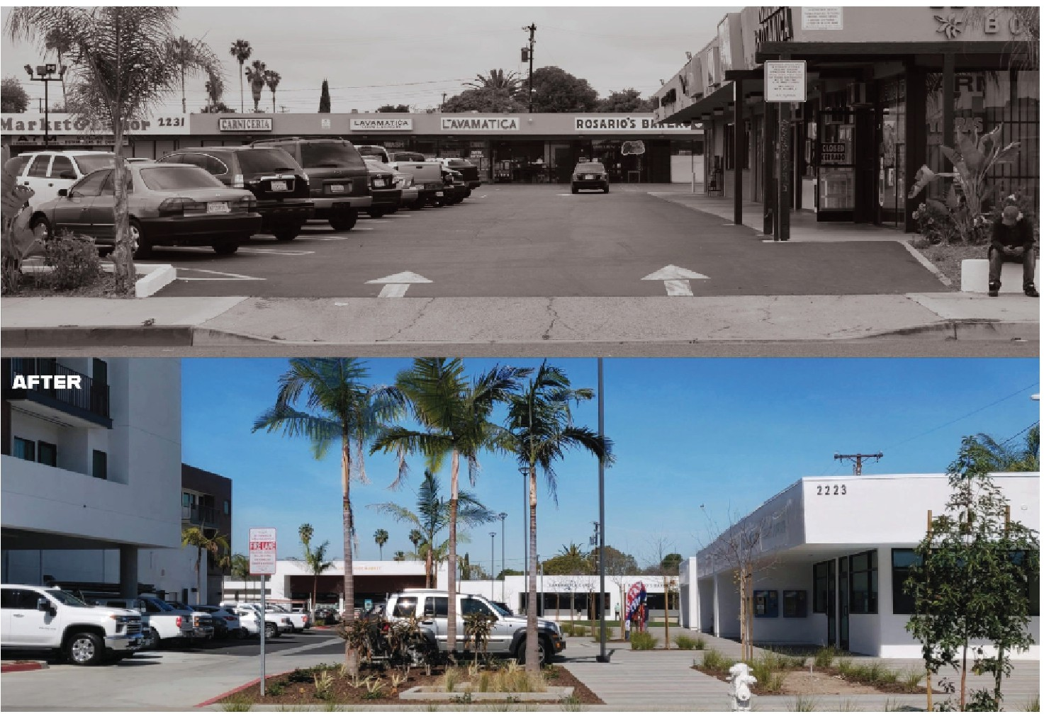
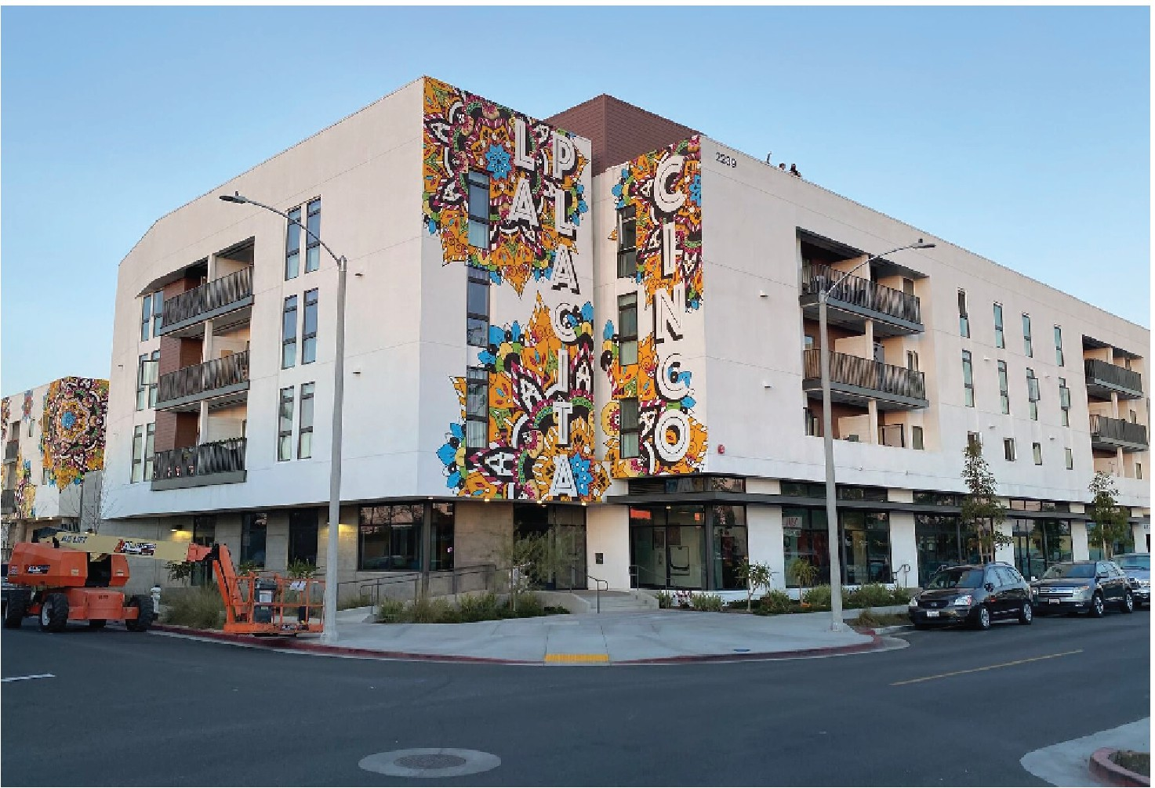

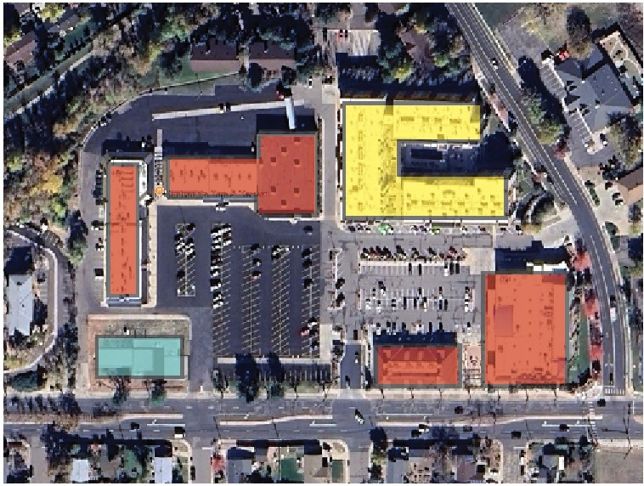

Louisville, CO
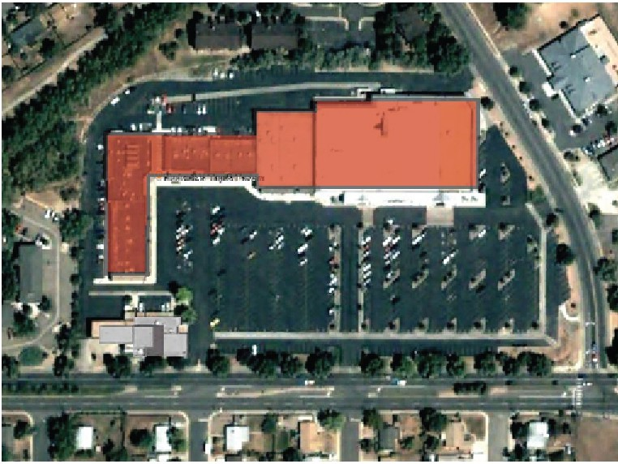
Diversity uses and building types; create a porous sitedtypes and styles and
Convert drive lane into a street

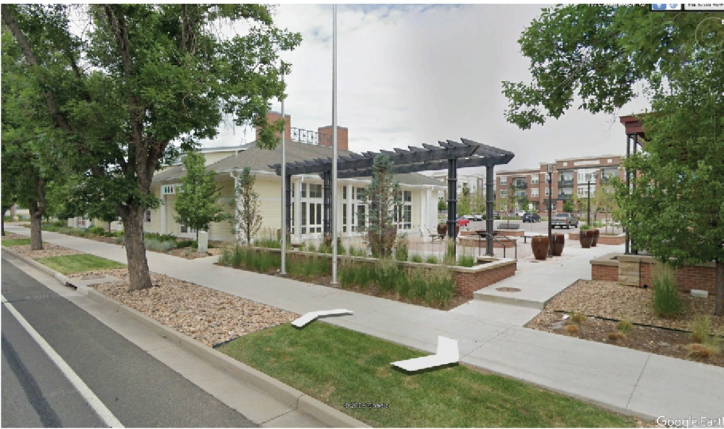
Placemaking between pavillion building and Grocery store
Add housing on unused parking

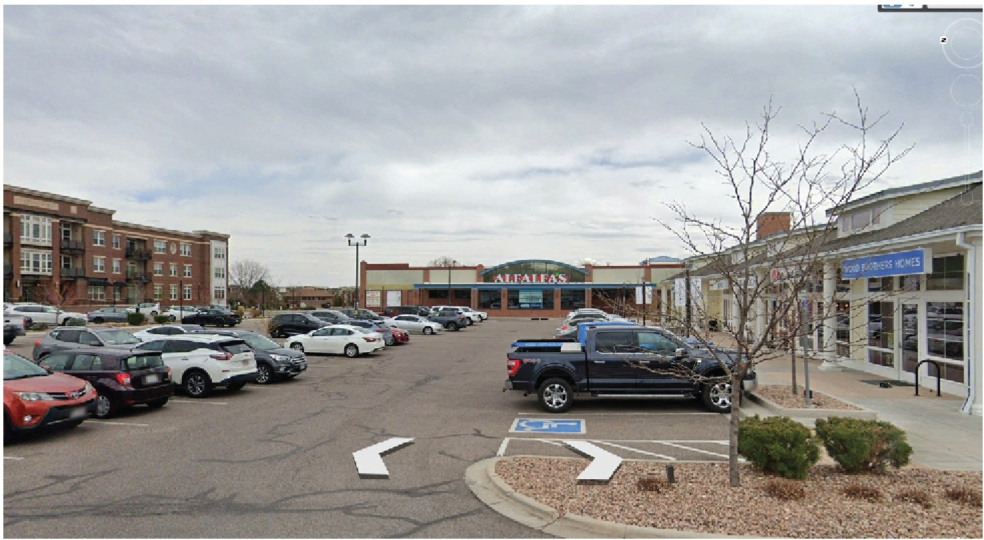
Placemaking between pavillion building and Grocery store

Step by Step Redevelopmment

Existing
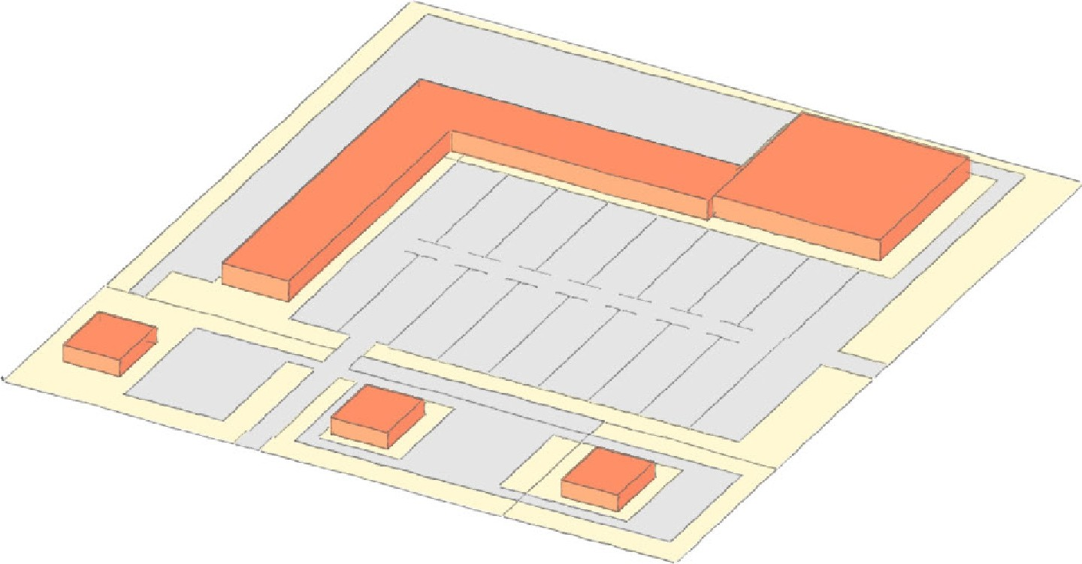

Step 1 Step 2 Step3

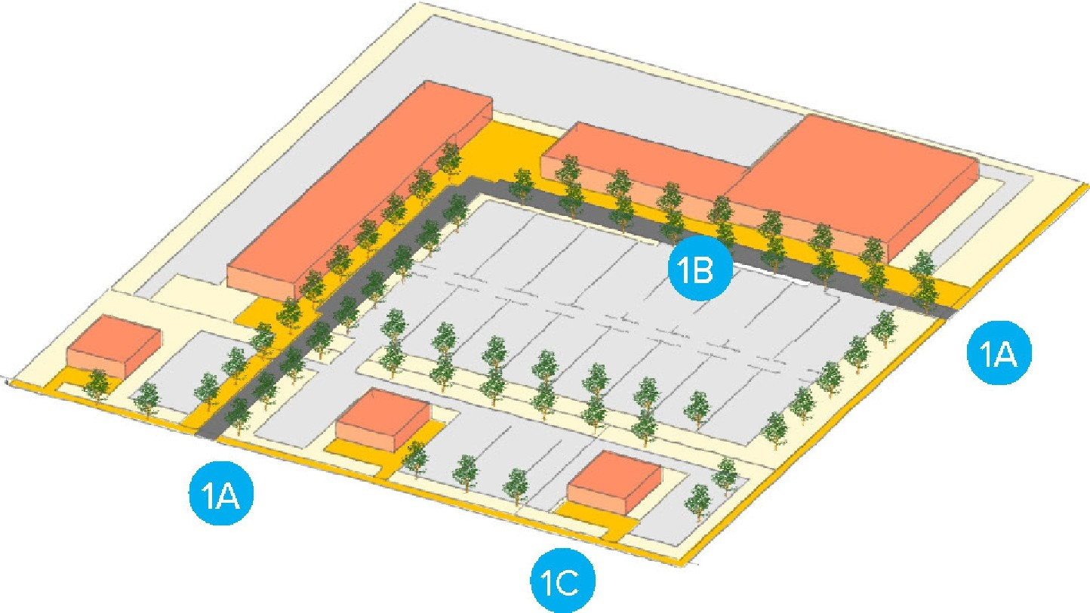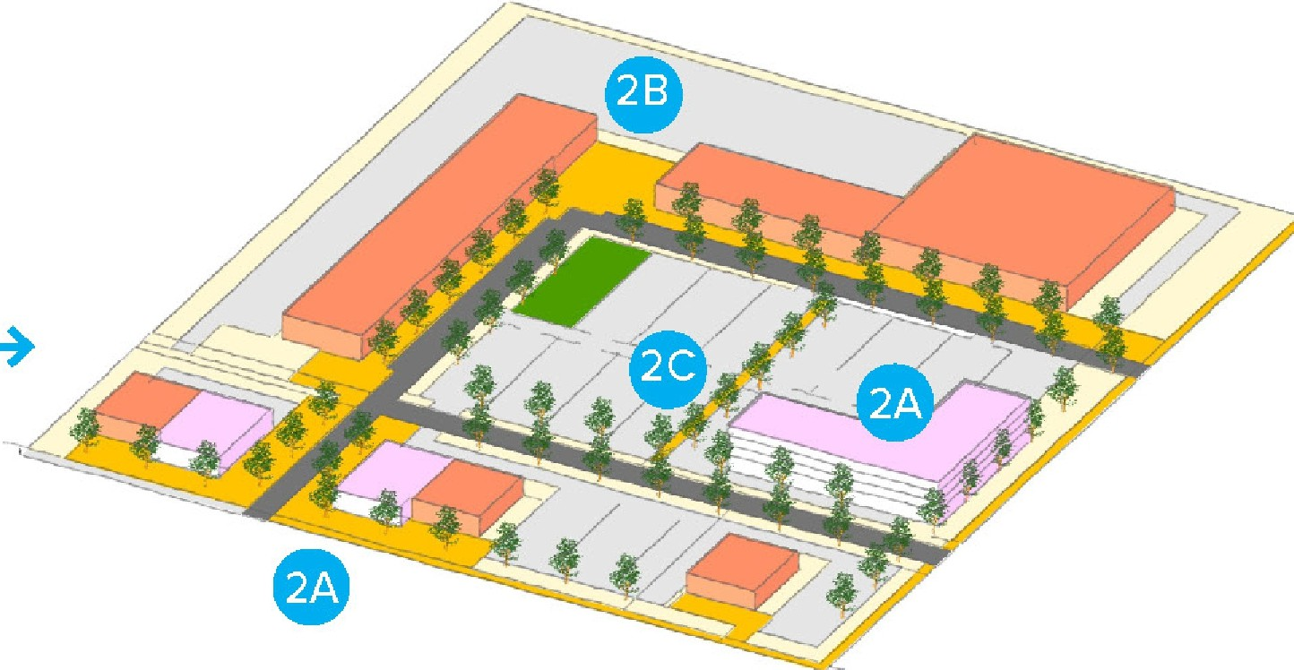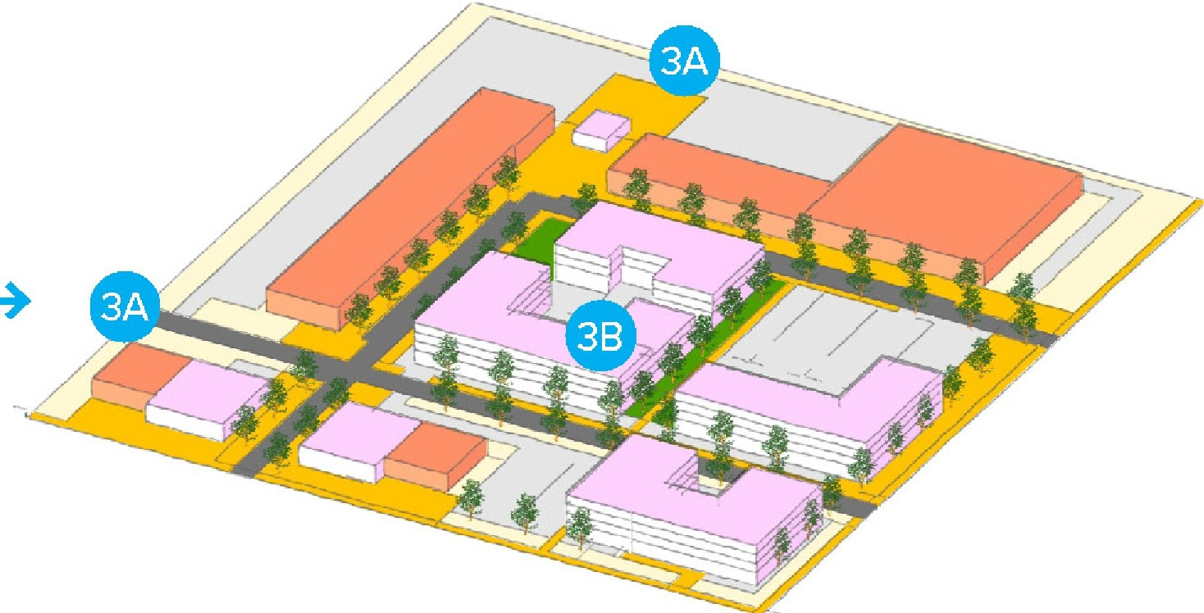

1A Reposition access 18: Build internal streets
1C: Transition Outlet Frontages
2A: Redevelop unused parking lots 28: Add public realm
2C: Create parking rooms
3A: Extend connections.
38: Redevelop with Shared parking

